Effects of spatio-temporal lakeside human disturbance on nearshore periphyton communities in Flathead Lake (Montana, United States)

Michael F. Meyer1*

Shawn P. Devlin2

Aaron W.E. Galloway3

Julie B. Schram3

Bradley T. Luff1

Matthew R. Brousil­4

Stephanie E. Hampton4

1School of the Environment, Washington State University, Pullman WA USA

2Flathead Lake Biological Station, University of Montana, Polson MT USA

3Oregon Institute of Marine Biology, University of Oregon, Charleston OR USA

4Center for Environmental Research, Education, & Outreach, Washington State University, Pullman WA USA

*Corresponding author (michael.f.meyer@wsu.edu)

Keywords: PPCPs, fatty acids, stoichiometry, food webs

**Abstract (194 of 200 words)**

Nutrients from lakeside developments can reshape aquatic ecosystems. Algal communities, especially in oligotrophic lakes, can rapidly sorb nutrients, causing increased biomass and altered resources for grazers. However, associating times and locations of nutrient loading with biological responses can be complicated, as spatio-temporal heterogeneities in nutrient loading and biological succession can obfuscate patterns. To evaluate how variation in nutrient addition may be associated with algal succession and nutritional quality, we sampled 16 littoral sites in Flathead Lake (Montana U.S.) from June through September 2017, when tourism dynamics may create variation in nutrient influx. As indicators of anthropogenic nutrient additions, pharmaceutical and personal care product (PPCPs) concentrations were measured fortnightly. Periphyton community composition, stoichiometry, and fatty acids were assessed monthly. PPCPs, including caffeine, nicotine, and warfarin were detected, and PPCP concentrations varied with seasonal tourist activity and proximity to decentralized sewage treatment. These same locations were associated with increased chlorophyte abundance, higher quality stoichiometric nutrition, yet lower quality omega-3 polyunsaturated fatty acids. Overall, our results suggest that sewage treatment techniques and seasonal human activity can create hot spots and hot moments for nutrient addition, thereby reshaping algal community compositions and available nutrition to the food web.

**Introduction**

Pollutants in wastewater released from lakeside developments are a common human disturbance that can alter biological communities and reshape food webs. In particular, nutrients, such as nitrogen and phosphorus, within treated and untreated wastewater can increase biomass and eventually lead to system-wide changes in algal community composition and production (Edmondson 1970) with potential consequences for higher trophic levels (Galloway and Winder 2015). Although nutrients in sewage have been shown to drastically alter aquatic ecosystems, explicitly linking increased nutrient concentrations and biological responses to sewage can be challenging, as nutrients can originate from disparate anthropogenic and natural environmental sources. For example, agriculture (Powers et al. 2016), melting permafrost (Turetsky et al. 2000), wildfires (Hohner et al. 2016), and even changing terrestrial plant communities (Moran et al. 2012) can all contribute nutrients into aquatic systems, potentially obfuscating clear sewage signals. In addition to the nutrients stemming from non-anthropogenic sources, biological processes can further confound sewage signals. Benthic primary producers, especially those in oligotrophic systems (Rosenberger et al. 2008; Hampton et al. 2011; Oleksy et al. 2020; Atkins et al. 2021), can scour nutrients quickly from the water column (e.g., hours), such that deviations in nutrient concentrations may not be detectable.

Because nutrients come from numerous non-sewage sources, indicators consistently associated with wastewater pollution, such as pharmaceuticals and personal care products (PPCPs) (Rosi-Marshall and Royer 2012; Meyer et al. 2019) as well as bacterial biomarkers (Seguel et al. 2001) have garnered attention for their usefulness as sewage indicators. PPCPs, such as caffeine, acetaminophen, and sulfamethoxazole, have been used to identify spatially and temporally heterogeneous sewage pollution in surface (Bendz et al. 2005) and subsurface (Yang et al. 2016) aquatic systems. Unlike nutrients within sewage, PPCPs tend not to be actively removed from the water column by biota, although certain algal (Bai and Acharya 2017) and animal (Meador et al. 2016; Arnnok et al. 2017; Richmond et al. 2018) taxa can uptake certain PPCPs from a mixture. Because PPCPs tend not to be actively accumulated by biota, their concentrations tend to be directly proportionate to increasing human population and inversely proportional with distance from population centers (Meyer et al.; Bendz et al. 2005). Similar to PPCPs, microbial and bacterial biomarkers, such as branched- and odd-chain fatty acids, can be useful for defining areas and moments of sewage loading (Seguel et al. 2001). In contrast to PPCPs, bacteria-associated fatty acids can be less specific sewage indicators, as bacteria can also originate from numerous non-sewage sources. However, tracking changes in relative bacterial abundance can be a reliable indicator of spatial patterns in sewage loadings (Timoshkin et al. 2016), where locations and timepoints with higher bacterial biomarkers would be more associated with sewage inputs. Perhaps more powerful, co-located PPCP and bacterial biomarker measurements can be useful to strongly infer and support the spatial extent and timing of sewage pollution into an ecosystem.

The effects of wastewater pollution are often first observed among littoral benthic communities, where increased nutrients can alter algal community succession by causing deviations in composition and abundance (Meyer et al.; Rosenberger et al. 2008; Hampton et al. 2011; Timoshkin et al. 2016; Bondarenko et al. 2021; Atkins et al. 2021). Previous syntheses have demonstrated that increased chlorophyte abundance over the course of summertime succession is a regularly occurring phenomenon in oligotrophic systems, where chlorophytes increase in abundance over the growing season and then eventually decrease relative to diatoms and cyanobacteria (Sommer et al. 1986, 2012). Mechanistically, this transition occurs when nitrogen and phosphorus become limiting for many chlorophyte taxa. In the case of sustained wastewater inputs, chlorophyte taxa can establish and remain dominant within the community (Timoshkin et al. 2016; Volkova et al. 2018; Ozersky et al. 2018), likely due to their increased efficiency at removing nutrients from the water column relative to diatoms (Rosenberger et al. 2008; Oleksy et al. 2020). In the case of punctuated wastewater inputs, chlorophyte taxa may increase in relative abundance both in response to nutrient inputs and as part of successional phenology, but then become displaced by other taxa as the community undergoes succession (McCormick and Stevenson 1991; Azim et al. 2005). These two dichotomous disturbance regimes, therefore, present two similar yet diverging mechanisms where nutrient addition into aquatic environments can alter anticipated periphyton successional patterns.

With community compositional shifts, nutrients from wastewater can influence nutritional quality of the periphyton, posing consequences for higher trophic levels. Periphyton fatty acids and C:N:P stoichiometric ratios, for example, are two paradigms for evaluating available nutrition that can diverge when assessing how wastewater can influence periphyton nutritional content. Fatty acids reflect changing nutritional content as a function of altered community composition, where chlorophyte, cyanobacteria, and diatoms each contain a taxon-specific multivariate fatty acid signatures (Kelly and Scheibling 2012; Taipale et al. 2013; Galloway and Winder 2015). In particular, the essential fatty acids (EFAs) are where these groups diverge the most, with diatoms being associated with 20:5ω3, chlorophytes being associated with 18:3ω3 and 18:2ω6, and cyanobacteria usually not containing any EFAs (Taipale et al. 2013; Galloway and Winder 2015). In contrast to fatty acids, stoichiometric C:N:P ratios can also suggest periphyton nutrition (Kahlert et al. 2002; Fink et al. 2006), but stoichiometry is not necessarily able to discriminate between community compositions in the same way as fatty acids. Rather, stoichiometric ratios can fluctuate as algal communities undergo succession, but the fluctuation is more in response to environmental conditions such as light and nutrient availability than community composition (Frost and Elser 2002). Chlorophyte taxa, especially filamentous chlorophyte taxa such as *Spirogyra spp*. and *Ulothrix spp*., are efficient at removing nutrients from the water column (Rosenberger et al. 2008; Oleksy et al. 2020) and when excess nutrients are available, these taxa can increase in abundance relative to diatoms, such that the periphyton community’s overall stoichiometric nutrition increases (Frost and Elser 2002). However, periphytic taxa can have complex life histories that can cause wide deviations in the periphyton’s composite stoichiometric ratios, such as diatoms retaining intracellular nitrogen and phosphorus but producing carbon-rich extracellular matrices (Frost et al. 2005). When considering how periphyton community nutrition may alter in response to sewage loading, successional shifts from diatom-dominated to chlorophyte-dominated communities may be expected to decrease in 20-Carbon EFAs and increase in less nutritious 18-Carbon EFAs; simultaneously, these communities may become stoichiometrically more nutritious (i.e. decreased C:N and C:P ratios), especially considering that filamentous chlorophytes can rapidly assimilate nutrients from the water column (Oleksy et al. 2020).

To investigate how sewage-associated nutrient addition can alter nearshore periphyton community compositions and standing nutritional resources, we surveyed 14 littoral locations in Flathead Lake (Montana, United States) throughout the tourism season for indicators of sewage pollution and metrics of periphyton community abundance and nutritional content. Flathead Lake is a large, deep, oligotrophic lake in western Montana (Young 1935). With Glacier National Park covering approximately one third of the lake’s watershed, Flathead Lake’s catchment is largely unpopulated, despite gradual increases in permanent and seasonal human population throughout the previous century (Stanford et al. 1994a). Within Flathead Lake’s basin, areas with intensive development have shown clear, distinct signs of sewage pollution, evidenced by pharmaceutical and personal care product (PPCPs) and volatile organic compounds detected in the subsurface (Tappenbeck and Ellis 2010, 2011). As locations with dense human population are generally located away from the lake, (e.g., > 20 km), Flathead’s pelagic is broadly oligotrophic, likely due to the lake’s exceptionally low hydraulic residence time (~3 years; Stanford et al. 1983) relative to its size (Messager et al. 2016). While the human population in Flathead Lake’s watershed is low, the littoral areas with adjacent lakeside development have been suspected of localized sewage pollution (Stanford et al. 1994a), evidenced by sustained increases in periphyton biomass since the 1980s. In particular, littoral sites without adjacent centralized wastewater treatment infrastructure (e.g., sewage treatment plants) have demonstrated signs of nonpoint nutrient addition, which could be contributed from decentralized forms of wastewater management such as septic tanks (Stanford et al. 1994a; Makepeace and Mladenich 1996). These same lakeside developments also tend to experience large tourism activity throughout the summer, where a reliance on decentralized sewage treatment could create moments of increased nutrient loading during the tourism season followed by reduced sewage loading after the tourism season. Similarly, littoral areas near locations with centralized sewage treatment also experience increased tourism during the summer, but sewage management infrastructure is often designed to scale with increases in human population, meaning that these areas likely experience consistent but elevated wastewater pollution relative to locations with decentralized wastewater infrastructure.

Given the evidence that Flathead’s periphyton communities may be responding to sewage inputs, our goal was to understand how spatially and temporally heterogeneous nutrient loadings from seasonal tourism may alter algal community composition and, thus, the available nutrition to the food web. This goal can be divided into three specific objectives:

1. identify areas and moments of wastewater pollution using sewage-specific indicators,
2. assess the relationship between sewage-specific indicators and periphyton community composition
3. evaluate how periphyton community compositional shifts may correspond with altered nutritional quality.

We hypothesized that (1) sewage-specific indicators, such as PPCP concentration as well as branched- and odd chain fatty acids, would increase near areas and moments with increased population density, proximity to lakeside development, and decentralized sewage treatment; (2) an elevated sewage signal would correspond with increased dominance of filamentous benthic algae; (3) increased filamentous algal presence should increase the stoichiometric nutrition but decrease fatty acid nutrition of the periphyton community; and (4) sites with consistent sewage indicators (i.e., those near centralized wastewater treatment) would correspond with less temporal fluctuation in periphyton community composition and nutrition status relative to sites with temporally fluctuating sewage indicators (i.e., sites near decentralized wastewater treatment systems).

**Methods**

*Site description*

Although most of Flathead Lake’s 260-km shoreline contains some degree of lakeside development, the vast majority of Flathead’s basin is unpopulated and roadless (Stanford et al. 1994a; Makepeace and Mladenich 1996). Approximately 33% of the basin’s area includes Glacier National Park, a nature preserve with little human development. Located approximately 23 km from the lake, the city of Kalispell is the largest population hub within the basin with approximately 23,000 residents (U.S. Census, 2019). The Flathead River runs through Kalispell and the main surface input to Flathead Lake. The Flathead River is Flathead Lake’s only surface outlet, where the river flows into Flathead in the northeast region near the town of Bigfork and exits in the southwest near the town of Polson with approximately 4,900 residents (U.S. Census, 2019). The Swan River is the second largest surface input into Flathead. Unlike the Flathead River, the Swan River does not run through large population hubs.

While main population hubs are concentrated away from Flathead’s shoreline, five main lakeside developments that host annual summertime tourists have demonstrated signs of nutrient pollution. Each of these main tourist hubs have different permanent population sizes and infrastructures for handling human population fluctuations, ranging from centralized wastewater treatment plants with tertiary treatment to septic systems. As such, our study focused on 15 littoral sampling locations throughout the lake repeatedly from late May through late September 2017. All sampling sites were chosen to represent a range of lakeside development sizes - spanning from sites with centralized sewage treatment and permanent housing to seasonally occupied developments with septic systems. Many sampling locations were located within Montana State Parks, which ensured consistent access to sampling locations throughout the course of a summer. To evaluate potential sewage contributions from Kalispell, one location was located in the Flathead River, upstream of the town of Big Fork. Sampling locations ranged from 0.5-8.0 m from shore and all sampling occurred at a depth of approximately 0.75-1.25 m, depending on wave activity and periphyton accessibility. During each sampling event, air and surface water temperature were measured with an alcohol thermometer, qualitative wave intensity (e.g, mild, moderate, strong waves), and whether or not tourists were present at time of sampling were recorded.

*Temporally-Scaled Inverse Distance Weighted (TSIDW) Population Calculation*

We recognized that sewage indicator presence was likely spatially related to the human population density of and distance from lakeside developments as well as temporally related with the time sample collection relative to the seasonal tourist visitations. Therefore, we created a metric that would represent both the human population density at a given sampling site as well as how that population might vary throughout a summer. Additionally, Makepeace and Mladenich (1996) suggested that anthropogenic nutrient loading into Flathead lake was likely driven by subsurface flows, meaning that the length of development’s shoreline (or the size of a development's interface with the lake) was likely directly proportionate to the amount of wastewater that could enter the lake. Building on techniques described in Meyer et al (Under Revision) and concepts expressed in Bendz et al (2005), we created a temporally-scaled inverse distance weighted (TSIDW), which considers that sewage indicator levels are likely directly related to population density, a lakeside development’s shoreline length, and level of tourism as well as inversely related to a sampling location’s distance from lakeside developments.

Analytically, the TSIDW population metric is meant to capture both spatial and temporal variation of human activity at each sampling location. The actual formulation of TSIDW population can be broken into two main components: (1) the static inverse distance weighted (IDW) population and (2) a temporal scalar of how much the lakeside human population changes through time. First, the static IDW population can be calculated in five main steps (Meyer et al, Under Revision). Municipality boundary and shoreline geometries were drawn using Google Earth and census delineations for five main lakeside municipalities. Shapefiles were then exported from Google Earth as a .kml file, and then imported into the R Statistical Environment (R Core Team 2019), in which shoreline length as well as municipality area and centroid were calculated using the sf package. Static IDW population was then calculated by summing the distance-weighted, shoreline length-scaled population density to each sampling location relative to each of the five lakeside municipalities. Second, the static IDW population was scaled by the average monthly temporal change in human population. In this case, state park visitation records were used to track changes in the human population relative to pre-tourism visitation levels. To track how the lakeside human population may change spatially and temporally, we collected visitor passes issued at each of the five state parks around the lake (Figure 1). These data aggregated both day-visitor as well as overnight visitors passes purchased within a month, thereby representing the total number of visitors to each of the five lakeside parks. To estimate a deviation in human population due to tourism, we normalized each park’s monthly visitors by the number of visitors to the same park in May, and as such this calculation assumes that the number of visitors in May is characteristic of the pre-tourism season. Because each state park was not necessarily located within or adjacent to the five main lakeside population hubs, we weighted each temporal scalar by the distance a given sampling location is from the centroid of each state park and then averaged the temporal scale for a given month. Averaging the temporal scalar helped us account for populations that may not be visiting a local park or correct for populations may have been dispersed when one of the parks was closed near the end of the tourist season.

Mathematically, TSIDW population can be expressed by equation 1:

$$I_{i,m}=\frac{1}{5} \sum_{q=1}^{q=5}{\frac{\frac{n_{m,q}}{n_{May,q}}}{D_{i,q}}}×\sum_{j=1}^{j=5}{\frac{\frac{P_{j}}{A_{j}}* L_{j}}{D_{i,j}}}$$

where the left summation is the Temporal Scalar formulation and the right summation is the spatial IDW population formulation. The equation is intended to represent the TSIDW population *I* at site *i* in month *m*. The IDW formulation considers the population size *P*, area *A*, and shoreline length *L* at development site *j* and weights the shoreline population by the distance from site *i* to *j*. The temporal scalar formulation considers the number of visitor passes sold *n* in a month *m* at park *q* relative to the number of passes sold in May at park *q* and weights this ratio by the distance of sampling site *i* from park *q*. When multiplied, the TSIDW population is meant to capture the temporal change and spatial position of human population around the lake’s perimeter, where sites with large populations but low tourism retain a high TSIDW throughout the summer whereas sites with smaller population experiencing larger waves of tourism relative to the development’s size are able to capture these deviations in lakeside human population throughout the summer.

*Pharmaceuticals and Personal Care Products (PPCPs)*

Water column Pharmaceutical and Personal Care Product (PPCP) samples were collected in duplicate fortnightly at a depth of approximately 0.5 m at each sampling location. Samples were collected in 1-L amber glass bottles that had been rinsed with lake water prior to collection. Samples were kept on ice and out of direct sunlight in a cooler while in the field and then placed in a refrigerator at ~4℃ upon return to the lab. While in the field, personnel collecting samples refrained from caffeine, nicotine, and other non-prescription medications on the days of sample collection, so as to avoid potential contamination.

Within 96 h of collection, samples underwent a solid phase extraction (SPE). Samples were filtered directly from the amber glass bottle using an in-line Teflon filter holder with glass microfiber GMF (1.0 µm pore size, WhatmanGrad 934-AH) in tandem with a solid phase extraction (SPE) cartridge (200 mg HLB, Waters Corporation, Milford, MA) connected to a 4-liter vacuum flask. Lab personnel wore gloves and face masks when handling samples in the lab to minimize potential for contamination. Prior to filtration, SPE cartridges were primed with at least 5 mL of either methanol or acetone and then washed with at least 5 mL of sample water. Rate of extraction was maintained at approximately 1 drop per second. Extraction proceeded until water could no longer pass through the SPE cartridge or until all collected water was filtered. Cartridges were stored in Whirlpacks at -20°C until analysis for 10 PPCP residues using high performance liquid chromatography tandem mass spectrometry (HPLC-MS) following methods of Furlong et al. (2008), Lee et al. (2016), and D’Alessio et al (2018). During the mass spectrometry sample processing, blank samples with methanol as well as a 20 µg/L standard were processed after every tenth sample. This step was added as a quality assurance protocol to flag instances of and correct for cross-sample contamination as well as peak drift when running samples over multiple hours. Concentrations are reported in µg/L. Samples were processed at the Water Environmental Research Laboratory at Washington State University.

*Nutrients*

Water column nutrient samples were collected at 14 of the 16 sampling locations and contemporaneously with the August and September PPCP sample collection that occurred at the end of the month (i.e., second fortnightly sampling campaign within a month). Samples were collected in 0.5-L plastic Nalgene bottles that had been rinsed with lake water prior to collection. Samples were kept on ice and out of direct sunlight in a cooler while in the field and then placed in a refrigerator at ~4°C upon return to the lab. Prior to freezing, phosphorus samples were transferred directly to a clear 60-mL HDPE Nalgene bottle. Nitrate/Nitrite samples were first filtered through a 0.45 µm nitrocellulose filter to remove intracellular nitrogenous species. Samples were processed using a spectrophotometer. Detection limits were estimated to be 1.5 µg/L-N for nitrogen samples and 0.8 µg/L-P for phosphorus samples.

*Periphyton Sample Collection*

Periphyton samples were collected at 14 of the 16 sampling locations and contemporaneously with PPCP sample collection that occurred at the end of the month (i.e., second fortnightly sampling campaign within a month). Two sampling locations (Holt and Ducharme) were largely characterized by clay and silt sediments, making standardized, systematic periphyton collection difficult. The remaining 14 locations could be broadly comparable with respect to the substrate, which could be characterized as a mix of large, oblate rocks and gravel. As such, we do not include data from HO and DU in our analysis.

At each of the periphyton sampling locations, nine rocks were haphazardly collected and placed into plastic, Ziplock bags within the field. Within 18 h of collection, a plastic stencil was used to define a surface area of each rock from which we scraped a standardized 1.61 cm2 patch of periphyton with a firm bristled toothbrush. Individual samples from three rocks were transferred to 50 mL plastic falcon tubes for abundance estimates. Glutaraldehyde (0.2% final volume) was added to each falcon tube as a preservative. Individual samples from four other rocks were transferred to GF/Fs for ash free dry mass estimates and DNA extraction. Following standardized area scrapes, all remaining periphyton on each of the nine rocks was scraped from the rock and into an aluminum tray. The composite periphyton mixture for a given site and sampling time was then placed into 50 mL plastic falcon tubes, which were centrifuged at ~750 rpm for 20 minutes so as to concentrate periphyton at the bottom of the tube. Using a 5-mL transfer pipette, visibly compacted periphyton and sediment were removed from falcon tubes and transferred to 1.5-mL Eppendorf tubes until a maximum of 10 Eppendorf tubes were filled with periphyton and sediment. These composite periphyton samples were then placed in a -80℃ freezer until processing for stoichiometry and fatty acids.

*Benthic algal abundance*

Periphyton taxonomic identification and enumeration was performed by subsampling 30 μL aliquots from each preserved sample using a compound light microscope. For all 30 μL aliquots, cells and filaments were counted, for the entire subsample, until at least 300 cells were identified for a given sampling replicate. If the first aliquot contained less than 300 cells, we counted additional subsamples until we reached at least 300 cells in total. In instances when 300 cells were counted before finishing a subsample, we still counted the entire aliquot. Taxa were classified into broad categories consistent with periphyton algal (Biggs and Kilroy 2000), using coarse groupings to capture general patterns in relative algal abundance. As a result, algal groups consisted of diatoms, chlorophyta, cryptophyta, chrysophyta, and cyanobacteria. For consistency, all samples were processed by one person (MFM), so as to reduce cross-observer error.

*Ashed Dry Mass*

GF/Fs were removed from whirlpacks, placed on aluminum foil, and transferred to a drying oven at ~96°C overnight. Samples were then relocated to a dessicator for at least 24 h. After samples were ensured to be dry, samples were weighed to the nearest 0.0001 g, and then placed in a muffle furnace at 550°C for ~1.5 h. After cooling for ~30 minutes, samples were massed again, and pre- and post-ignition were differenced. Samples were processed at the Water Environmental Research Laboratory at Washington State University.

*Periphyton Stoichiometry*

Two 1.5-mL Eppendorf tubes of concentrated periphyton for each sampling location and time were transferred to a foil pan and allowed to thaw and dry in a drying oven at 60°C overnight. Samples were then homogenized and placed in a desiccator for at least one hour prior to weighing.

Two subsamples of completely dried periphyton were transferred to two glass scintillation vials and covered with foil. Particulate carbon and nitrogen measurements could be processed together and required at least 50 mg of tissue, whereas particulate phosphorus required a separate instrument and no more than 5 mg of tissue for analysis. Samples were combusted at ~500°C for 4.5 h, and once cooled, 10 mL of 0.15 M hydrochloric acid was added. Samples were stored at 4°C until analyzed. For particulate carbon and nitrogen, analysis occurred using a Leco CN628 analyzer. For particulate phosphorus, analysis occurred using an Astoria Pacific, A2 segmented flow analyzer with an Astoria Pacific models 311 XYZ autosampler. The method detection limits were estimated to be 2 μg/L-P. Samples were processed at the Freshwater Research Laboratory at Flathead Lake Biological Station.

*Periphyton Fatty Acid Analysis*

All collected periphyton samples in 1.5-mL Eppendorf tubes that were not used for stoichiometric assessment were allocated for fatty acids. Samples were allowed to freeze-dry overnight. Following freeze-drying, samples were transferred to 10 mL glass centrifuge vials, and 2 mL of 100% chloroform was added to each under nitrogen gas. Samples remained in chloroform overnight at -80°C. Fatty acid extractions generally involved three phases: (1) 100% chloroform extraction, (2) chloroform-methanol extraction, and (3) fatty acid methylation. Fatty acid extraction methods were adapted from Schram et al. (2018).

After overnight chloroform extraction, samples underwent a chloroform-methanol extraction three times. To each sample, we added 1 mL cooled 100% methanol, 1 mL chloroform:methanol solution (2:1), and 0.8 mL 0.9% NaCl solution. Samples were inverted three times and sonicated on ice for 10 minutes. Next, samples were vortexed for 1 minute, and centrifuged for 5 minutes (3,000 rpm) at 4°C. Using a double pipette technique, the lower organic layer was removed and kept under nitrogen. After the third extraction, samples were evaporated under nitrogen flow, and resuspended in 1.5 mL chloroform and stored at -20°C overnight.

Once resuspended in chloroform, 1 mL of chloroform extract was transferred to a glass centrifuge tube with a glass syringe as well as an internal standard of 4 μL of 19-carbon fatty acid. Samples were then evaporated under nitrogen, and then 1 mL of toluene and 2 mL of 1% sulfuric acid-methanol was added. The vial was closed under nitrogen gas and then incubated in a 50°C water bath for 16 hours. After incubation, samples were removed from the bath, allowed to reach room temperature and stored on ice. Next, we performed a potassium carbonate-hexane extraction twice. To each sample, we added 2 mL of 2% potassium bicarbonate and 5 mL of 100% hexane, inverting the capped vial so as to mix the solution. Samples were centrifuged for 3 minutes (1,500 rpm) at 4°C. The upper hexane layer was then removed and placed in a vial to evaporate under nitrogen flow. Once almost evaporated, 1 mL of 100% hexane was added and stored in a glass amber autosampler vial for GC/MS quantification. GC/MS quantification was performed with a Shimadzu QP2020 GC/MS following Schram et al. (2018). Samples were processed at the Community Trophic Ecology Laboratory at the Oregon Institute for Marine Biology.

*Statistical Analysis*

To evaluate how spatial and temporal variation in lakeside development and human activity may contribute sewage indicators into the nearshore, we performed a series of ANOVAs with sewage treatment technique (e.g., decentralized or centralized) and temporal position to tourist season (e.g., in-season, off-season) as predictors of TSIDW population, total PPCP concentration, abundance of branched- and odd-chain fatty acids, nitrogen, phosphorus, and ashed dry mass. Predictors were treated as fixed effects, and because the sampling design was unbalanced, we used a Type II SS formulation (Langsrud 2003).

To determine how spatial and temporal variation in lakeside development and human activity may influence periphyton community composition, we first performed a non-metric multidimensional scaling (NMDS) with Bray-Curtis similarity, and then visualized the NMDS in two dimensional space. Because Chrysophyta and Cryptophyta were rare (i.e., < 2% of the intersite abundance), we omitted these taxa from analysis and visualization. To test differences between relative abundance, we performed a permutational multivariate analysis of variance (PERMANOVA; Anderson 2001) with 999 permutations, where sewage treatment technique (i.e., decentralized or centralized) and temporal position to tourist season (i.e., in-season, off-season) were predictors of relative periphyton community abundance. Unlike traditional multivariate analyses of variance (MANOVA), PERMANOVA does not require assumptions of multivariate normality (Anderson 2001). When significant differences were identified, post-hoc SIMPER analysis (Clarke 1993) was performed to identify which taxonomic groups most influenced site separation. Recognizing that sites may not separate in multivariate space, we also performed univariate Type II SS ANOVAs, where NMDS1 and NMDS2 were responses to sewage treatment technique and tourist season. This analysis would ultimately allow us to examine clustering within the multivariate space that may be present when consider each NMDS axis independently.

To assess how spatial and temporal variation in lakeside development and human activity may influence periphyton stoichiometric ratios and fatty acid composition, we performed a series of ANOVAs with sewage treatment technique (e.g., decentralized or centralized) and tourist season timing (e.g., in-season, off-season) as predictors of Carbon:Nitrogen, Carbon:Phosphorus, and Nitrogen:Phosphorus.

To understand how sewage treatment technique and temporal position to tourism may influence multivariate fatty acid signatures, we performed a non-metric multidimensional scaling with Bray-Curtis similarity of all fatty acids constituting more than 1% of intersite proportions, and then visualized the NMDS in two-dimensional space. To test differences between relative fatty acid abundance, we performed a PERMANOVA with 999 permutations, where sewage treatment technique and temporal position to tourist season were predictors of the entire periphyton fatty acid profile. When significant differences were identified, post-hoc SIMPER analysis was performed to identify which fatty acids most influenced site separation. As with periphyton community composition, we also performed univariate ANOVAs with NMDS1 and NMDS2 scores as a response to sewage treatment technique and tourist season.

All data aggregation routines and statistical analyses were performed using the R Statistical Environment (R Core Team 2019) with the tidyverse (Wickham et al. 2019), vegan (Oksanen et al. 2019), car (Fox and Weisberg 2019), lubridate (Grolemund and Wickham 2011), stringi (Gagolewski 2020), janitor (Firke 2020), ggpubr (Kassambara 2019), ggrepel (Slowikowski 2019), viridis (Garnier 2018), rnaturalearth (South 2017), ggspatial (Dunnington 2021), ggstar (Xu 2021), cowplot (Wilke 2019), and sf (Pebesma 2018) packages. All R code can be accessed from this project’s GitHub Repository (DOI), and all associated can be found on this project’s Open Science Framework portal (DOI). All R scripts were written by one person (MFM) and then independently reviewed by another co-author (MRB) to assess scripts for accuracy, reproducibility, and clarity of comments.

**Results**

*Temporally Scaled Inverse Distance Weighted (TSIDW) Population*

Spatially, TSIDW population indicated higher human lakeside populations were clustered in the northeastern part of the lake, which is likely due to the town of Bigfork being a larger population hub (Figure 2). Temporally, TSIDW population highlighted the fluctuations in human population through time, in particular in the southernmost portion of Flathead Lake, near the town of Polson (Figure 2). Statistically, TSIDW population tended to be significantly higher at locations based on tourist season (F = 7.99, p = 0.006; Figure 4A) than sewage treatment technique, although patterns qualitatively suggested that lower human populations were generally near sites with decentralized wastewater treatment and higher human populations were located near sites with centralized wastewater treatment.

*Water Samples*

Nearshore nutrient concentrations differed significantly across our sampling locations and throughout time (Figure 3). Nitrate and nitrite concentrations were significantly higher at sites with decentralized sewage treatment (F = 6.35, p = 0.02), but there was no difference in concentrations based on temporal position in the tourism season (F = 0.05, p = 0.82) and the interaction of tourist season and sewage treatment technique (F = 1.33, p = 0.26). Ammonia concentrations were only significantly different for the interaction of sewage treatment technique and tourism season (F = 6.72, p = 0.01) but not for sewage treatment (F = 1.21, p = 0.28) and tourist season (F = 0.57, p = 0.45) independently. Soluble reactive phosphorus concentrations were significantly higher at sites with centralized sewage treatment (F = 23.79, p < 0.001), at timepoints following the tourist season (F = 7.93, p = 0.007), and there was a significant interaction between sewage treatment technique and tourist season (F = 26.45, p < 0.001). For bulk nutrients, total nitrogen (F = 12.23, p = 0.001) as well as total phosphorus (F = 4.57, p = 0.04) were significantly higher following the tourism season.

PPCPs detected within the water column included caffeine, paraxanthine/1,7-dimethylxanthine, acetaminophen/paracetamol, cotinine, cimetidine, and warfarin. PPCPs not detected included carbamazepine, codeine, diphenhydramine, sulfamethoxazole, thiabendazole, and trimethoprim. Total PPCP concentrations were only significantly different for the interaction of sewage treatment technique and tourist season (F = 4.97, p = 0.03; Figure 4B). When considering concentrations observed at sites with centralized and decentralized treatment separately, PPCP concentrations observed at sites with decentralized treatment were significantly higher during the tourist season (F = 4.82, p = 0.03; Figure 4B), whereas sites with centralized treatment did not significantly differ in PPCP concentrations based on tourist season (F = 1.40, p = 0.25; Figure 4B).

*Periphyton Community Composition*

Periphyton community composition largely consisted of chlorophytes, cyanobacteria, and diatoms (Figure 5), with cyanobacteria being more pronounced at sites with decentralized wastewater treatment. Visual inspection of the NMDS suggested that NMDS1 scores tended to separate according to tourist season and NMDS2 scores tended to separate based on sewage treatment technique (Figure 6A), but in multivariate space, none of these groups differed significantly. When considering each axis in univariate space, NMDS2 values did differ significantly based on sewage treatment technique (F = 7.13, p = 0.01; Figure 6B, 6C), whereas NMDS1 did not differ significantly based on tourist season or sewage treatment technique (Figure 6B, 6C).

*Periphyton Stoichiometry*

Periphyton C:N, C:P, and N:P molar ratios varied widely across sites and timepoints. Most values deviated substantially above optimal periphyton stoichiometry ratios of 119:17:1 (Hillebrand and Sommer 1999). Both C:P and N:P ratios did not differ based on sewage treatment technique or tourist season (Figure 7B, 7C). C:N ratios tended to be significantly lower at sites with centralized wastewater treatment in comparison to decentralized wastewater treatment (F = 5.83, p = 0.02; Figure 7A) but not for tourist season (F = 0.015, p = 0.90; Figure 7A).

*Periphyton Fatty Acids*

With respect to fatty acids more associated with bacterial communities, such as branched and odd-chain fatty acids, our samples contained 15- and 17-Carbon saturated as well as 15-Carbon branched fatty acids. Two-way ANOVA results suggested that relative abundance of branched and odd-chain fatty acids was significantly higher during the tourism season than outside of the tourism season (F = 6.06, p = 0.02; Figure 4C). When partitioning data based on type of wastewater infrastructure, sites with decentralized treatment caused this pattern, where relative branched and odd-chain fatty acids were higher during the tourist season than following the tourism season (F = 8.28, p = 0.009; Figure 4C). There was no difference in relative branched and odd-chain fatty acids within periphyton communities at sites near centralized wastewater treatment (Figure 4C).

With respect to the abundance of broad categories of fatty acids, such as saturated (SAFA), monounsaturated (MUFA), and polyunsaturated (PUFA) fatty acids, greatest two-way differences in relative fatty acid abundance were observed by increases in PUFAs following the tourist season (F = 14.72, p < 0.001; Figure 8) but no differences were noticed between types of sewage treatment. When partitioning data by wastewater infrastructure, differences in PUFA abundance were only noticed at sites with decentralized wastewater treatment (F = 13.58, p = 0.001; Figure 8) and not at sites with centralized wastewater treatment (Figure 8).

With respect to differences in essential fatty acids (EFA), the fatty acids with the highest coefficients of variation included 20:5ω3 and 18:3ω3 (Figure 9), which were likely reflective of differences in periphyton community composition. When analyzed visually through a univariate framework (Figure 9), periphyton EFAs at sites with centralized sewage treatment appeared to have more consistent proportions through time, whereas sites with decentralized treatment tended to have higher proportions of 20-Carbon EFAs, such as 20:5ω3. When analyzed in a multivariate framework (Figure 10A), visual inspection of the NMDS suggested that NMDS1 tended to generally separate based on fatty acids more associated with chlorophytes (i.e., 18:2ω6, and 18:3ω3) and fatty acids more associated with diatoms (i.e., 20:5ω3), and NMDS2 tended to separate based on the tourist season. PERMANOVA results suggested tourist season as significant in discriminating groups (F = 2.77, p = 0.01), and post-hoc SIMPER analyses suggested 20:5ω3 as the most influential discriminating fatty acid (Cumulative Variance = 37.6%, p = 0.04). Together, 20:5ω3, 18:2ω6, and 18:3ω3 accounted for more than 85% of the total variance. When assessing NMDS scores in univariate space, NMDS2 values were significantly different in response to tourist season (F = 13.03, p = 0.001; Figure 10B, 10C) but not for sewage treatment technique. For NMDS1, neither sewage treatment technique nor tourist season was significant (Figure 10B, 10C).

**Discussion**

Our combined results corroborate previous findings (e.g., Makepeace and Mladenich 1996) that sewage pollution is entering Flathead Lake’s nearshore area and likely is responsible for differences in nearshore periphyton community composition and nutritional content. Unlike previous studies in Flathead Lake (Stanford et al. 1994a; Makepeace and Mladenich 1996), we incorporated highly specific indicators of sewage pollution and periphyton nutritional content to describe how sewage pollution entering Flathead may be influence periphyton stoichiometry and fatty acid composition, thereby providing direct, quantitative evidence of how sewage entering Flathead may alter nutrition available to the lake’s larger food web.

*Relating human population with sewage indicators*

In agreement with our expectations, sewage-specific indicators tended to increase when lakeside human populations were larger and where lakeside developments relied on decentralized wastewater treatment infrastructure. Total PPCP concentrations were significantly higher during the tourism season as opposed to following the tourism season at sites with decentralized sewage treatment (Figure 4A). These patterns are noteworthy as Flathead’s watershed is largely unpopulated, but permanent and seasonal human populations have been growing since the 1950s (U.S. Census, 2020). In particular, many lakeside developments around Flathead Lake rely upon septic systems for wastewater treatment (Stanford et al. 1994a), and our data suggest that sites with decentralized sewage treatment tended to have increased PPCP concentrations during the tourist season. In contrast, sites with centralized sewage treatment tended to have higher PPCP concentrations relative those at decentralized sites, but sites with centralized sewage treatment also tended to have a more temporally consistent sewage indicators throughout the summer. Furthermore, spatial and temporal patterns in sewage indicator concentrations mirrored patterns observed in TSIDW population, suggesting that our samplings were able to capture spatially and temporally heterogeneous sewage loadings.

When comparing PPCP with nutrient concentrations, patterns in nutrient concentrations alone were not necessarily reflective of patterns observed with more specific indicators (Figure 3). These incongruencies are likely due to nutrients originating from non-sewage sources as well as nutrients being actively scoured and released into the water column through a suite of physicochemical and biochemical processes. For example, allochthonous nutrients can originate from fertilizers applied in directly adjacent lakeside orchards (Stanford et al. 1994a), pollen from conifers (Graham et al. 2006), and even forest fires (Gould et al. 2016) or atmospheric deposition more broadly (Elser et al. 2009). Throughout the course of our sampling campaign, wildfires, significant pollen deposition, and lakeside agriculture all occurred and likely contributed nutrients to Flathead’s nearshore communities, but these are currently not known to be significant nutrient sources in Flathead relative to sewage.

To our knowledge, this is the first study to detect PPCPs in Flathead Lake, a lake that is highly voluminous, has a short hydraulic residence time relative to its size (Messager et al. 2016), and is located in a largely unpopulated and undeveloped watershed (Stanford et al. 1994a). Previous investigations of sewage pollution into groundwater near Kalispell, Montana (the watershed’s most populous city with ~23,000 people; U.S. Census) have highlighted the potential for PPCPs to occur within Flathead’s watershed but from distal developments (Tappenbeck and Ellis 2010, 2011). Furthermore, it is currently unknown (1) how subsurface PPCP concentrations may enter surface flows through groundwater-surface water connections or (2) how PPCPs contributed from Kalispell may affect subsurface biota such as stonefly larvae (Stanford et al. 1994b; Stewart 2002; Malison et al. 2020). Our sampling scheme included one location within the Flathead River (HO; Figure 1), which runs through Kalispell and is the main surface input into Flathead Lake. Although we detected PPCPs at this site, concentrations were lower than those observed near the lakeside development of Bigfork, implying that concentrations observed in Flathead Lake likely originated from adjacent lakeside settlements and were not contributed from distal sources. More broadly, our results suggest that wastewater infrastructure as well as the size and temporal variation of human populations at adjacent lakeside developments can contribute spatially and temporally varying sewage inputs, thereby creating hot spots as well as hot moments of sewage pulses into the nearshore.

Beyond Flathead Lake, these data and results are important for understanding PPCP prevalence in lakes and sewage contributions from decentralized wastewater treatment. Despite rapid growth in the PPCP literature over the past three decades and worldwide, both lakes and forms of decentralized sewage treatment have remained far less represented in the literature relative to lotic environments and forms of centralized wastewater treatment (Meyer et al., 2019). These imbalances may be important for shaping our understanding of PPCPs in the environment. Lakes tend to have longer hydraulic residence times relative to lotic systems, meaning that pollutants within sewage may concentrate and elicit stronger biological responses. Likewise, decentralized wastewater treatment can contribute significant nutrient (Moore et al. 2003; Rosenberger et al. 2008; Hampton et al. 2011; Withers et al. 2014) and micropollutant (Meyer et al.; Bendz et al. 2005) loadings to proximal aquatic systems. Adding to this complexity, PPCPs contributed from septic systems have demonstrated complex transport dynamics that may influence their residence time, where some PPCPs, such as caffeine, can pulse through subsurface systems and enter into surface flows, yet some PPCPs, such as acetaminophen, can sorb to proximal colloidal materials, thereby creating PPCP hotspots (Yang et al. 2016). Considering that more than half of the world’s population utilizes some form of decentralized wastewater treatment (Withers et al. 2014), the current uncertainties around PPCP prevalence, PPCPs’ potential to accumulate and create pollution hot spots, and PPCPs’ often uncertain biological effects, our data underscore the potential for PPCP concentrations to vary spatially and temporally in lakes and highlight the need for continued study of the biophysical processes influencing their abundance.

While our study focused on using PPCPs as indicators of sewage, PPCPs themselves can elicit deleterious ecological responses, even at concentration we observed in Flathead (e.g., < 10 ng/L; Feijão et al. 2020). These responses can be complex and include a range of biological responses, from physiological (del Rey et al. 2011) and behavioral (Brodin et al. 2013) to food webs (Meador et al. 2016; Lagesson et al. 2016; Richmond et al. 2018) and ecosystems (Rosi-Marshall et al. 2013). Although our study was not designed to evaluate ecotoxicological effects of PPCPs on periphyton communities and especially higher trophic levels, future studies could build on this study as well as the empirical results of others to address how wastewater treatment infrastructure and swings in human population can create PPCP co-contaminants assemblages that affect biological communities differently across various spatial and temporal scales.

*Relating human population with periphyton community composition*

Congruent with our hypotheses, areas and timepoints with increased human population and sewage indicator abundance tended to be associated with increased filamentous chlorophyte taxa. These same patterns have been noticed in the nearshore of other large, deep, oligotrophic lakes, such as Lake Baikal (Meyer et al.; Timoshkin et al. 2016, 2018; Volkova et al. 2018), Lake Crescent (Rosenberger et al. 2008; Hampton et al. 2011), Lake Pend Oreille and Priest Lake (Rosenberger et al., 2008), and Lake Tahoe (Naranjo et al. 2019; Atkins et al. 2021). Aside from sewage inputs providing nutrients for chlorophytes to increase in abundance, filamentous chlorophyte taxa are also known to increase annually as part of algal successional patterns (Sommer et al. 1986, 2012). While current understanding of algal successional patterns tend to be based on phytoplankton dynamics, periphyton appear to undergo similar phenological shifts over the course of a summer (McCormick and Stevenson 1991; Stevenson et al. 1996; Azim et al. 2005), meaning that increased filamentous chlorophyte abundance from sewage could be confounded with patterns expected from an annually occurring phenomenon. Recent syntheses have likewise suggested increased allochthonous nutrients into oligotrophic lakes’ littoral zones may be responsible for increased filamentous algal abundance worldwide and eventually contribute to nuisance filamentous algal blooms (Vadeboncoeur et al. 2021). Yet, other mechanisms may be also responsible for these observed patterns. For example, seasonal wave action can transport hypolimnetic nutrients to the littoral zone and stimulate increased filamentous algal production (reviewed in Vadeboncoeur et al. 2021). Likewise, shifting environmental conditions, such as temperature or dissolved oxygen, may limit the capacity for macroinvertebrates to graze, allowing for quickly growing, filamentous algae to outcompete diatom taxa (reviewed in Vadeboncoeur et al. 2021). Regardless of the exact mechanism occurring in Flathead Lake, our algal abundance data are consistent with other nearshore sewage-associated eutrophication patterns observed in other, large, deep, oligotrophic systems, such as Lake Baikal (Meyer et al.; Timoshkin et al. 2016), Lake Tahoe (Naranjo et al. 2019), and Lake Crescent (Rosenberger et al. 2008; Hampton et al. 2011). By mirroring patterns in sewage-specific indicator abundance, our data further suggest that relative abundance of filamentous taxa tends to be greatest near areas and during times of increased human activity at lakeside developments.

Beyond algal community composition, relative abundance of periphyton branched- and odd-chain fatty acids, which are highly specific indicators of bacterial communities, mirrored patterns observed in total PPCP concentrations and algal taxonomic abundances. While bacteria are inherently parts of biofilm communities (Azim et al. 2005), their relative abundance can be useful for inferring sewage pollution and heterotrophic components of the periphyton community (Seguel et al. 2001; Rocchetta et al. 2014). Similar studies at Lake Baikal measured *E. coli* and *Enterococcus* abundances near areas suspected of increased sewage pollution and noted that these areas tended to have higher fecal indicator bacteria abundances (Timoshkin et al. 2016). While branched- and odd-chain fatty acids can suggest bacterial abundance (Seguel et al. 2001; Rocchetta et al. 2014), the diversity of branched- and odd-chain fatty acids observed in our data could not identify specific taxonomic groups that may be present. From an ecosystem productivity perspective, these differences in heterotroph abundance may be consequential for community function. Previous works have demonstrated how pollutants within sewage can alter bacterial community composition as well as community function. Rosi-Marshall et al. (2013), for example, demonstrated how caffeine can act as generalist toxicant and reduce community respiration by reducing abundance of the entire community, whereas diphenhydramine can act as a specialist toxicant and reduce community respiration by reducing certain taxa’s relative abundance. While our study was not designed to incorporate potential differences in heterotrophic assemblages within periphyton, the consistent patterns observed in periphyton branched- and odd-chain fatty acids in relation to sewage treatment technique and the tourist season in tandem with growing uncertainties in how sewage may influence heterotroph composition and function suggest that a non-autotrophic responses in Flathead and across lakes likewise deserves increased research emphasis.

*Relating human population with periphyton nutritional content*

Fatty acid analyses suggested that changes in periphyton community composition altered nutritional quality of periphyton across sites and timepoints. Periphyton fatty acids at sites with centralized sewage treatment tended to have consistent fatty acid ratios through time, although one site following the tourism season did have marked increases in PUFA proportions (YB; Figure 1). In contrast, periphyton fatty acid profiles at sites with decentralized sewage treatment tended to have a tradeoff between SAFAs and PUFAs throughout the course of the summer, where SAFAs decreased and PUFAs increased in relative abundance (Figure 8). These patterns are likely reflective of changes in the periphyton community composition, as periphyton taxa tend to have strongly differentiated multivariate fatty acid signatures (Taipale et al. 2013; Galloway and Winder 2015).

The same pattern of increased high-quality fatty acid abundance at decentralized sites following the tourism season is perhaps starker, when focusing on periphyton essential fatty acid (EFA) signatures. EFAs are a subgroup of PUFAs that accumulate in organisms, are primarily synthesized by primary producers, and can be vital nutrition to higher trophic levels (Iverson et al. 2004; Kelly and Scheibling 2012). Among the eight common fatty acids, 18:3ω3 and 20:5ω3 had the highest coefficients of variation across sites and timepoints. Both 18:3ω3 and 20:5ω3 are consistently associated with chlorophyte and diatom taxa (Taipale et al. 2013; Galloway and Winder 2015), respectively, meaning that the increased diatom presence at decentralized sites following the tourism season was likely responsible for increased 20:5ω3 relative abundance and for making 20:5ω3 the most influential fatty acid for separating EFA profiles based on tourism season (Figure 9). Together, our analysis of sewage indicators, periphyton composition, and fatty acid results suggest that Flathead’s nearshore periphyton communities near centralized sewage treatment tend to experience temporally consistent sewage loading that likely supports a regular assemblage of chlorophytes and diatoms, and therefore these sites maintain a temporally consistent fatty acid signature. In contrast, these same results suggest that Flathead’s nearshore periphyton communities near decentralized sewage treatment tend to experience inconsistent sewage loading that likely allows for tradeoffs in chlorophyte, cyanobacteria, and diatom relative abundance. Therefore, these sites maintain a temporally inconsistent fatty acid signature. In particular, sites with decentralized treatment tended to experience increased PUFA abundance, especially 20-carbon EFA, abundance following the tourism season, which could provide necessary nutrition to higher trophic levels as they prepare to overwinter.

In contrast to fatty acids, periphyton stoichiometric ratios tended to be lower at sites with centralized treatment, implying that sites with centralized treatment may actually have more nutritious periphyton. Unlike fatty acids, periphyton stoichiometric ratios do not to map to community composition, and furthermore, periphyton stoichiometric ratios may be influenced by ambient water column nutrient concentrations (Frost and Elser 2002), production of extracellular matrices or mucilage tubes (Frost et al. 2005), and taxon-specific uptake rates (Oleksy et al. 2020). Among each of the stoichiometric ratios considered, C:N ratios were the only ones that were different between locations and timepoints. The lack of differences between sites and timepoints for C:P and N:P ratios is not necessarily surprising, as phosphorus is usually a limiting element in oligotrophic Flathead (Axler and Reuter 1996). Conversely, C:N ratios were significantly lower at sites with centralized treatment than those at sites with decentralized treatment (Figure 7A). Mechanistically, the difference in C:N likely stems from chlorophytes’ increased abundance at sites with centralized treatment, as chlorophytes, especially filamentous chlorophytes, tend to more efficiently remove nitrogen from the water column relative to diatoms (Oleksy et al. 2020; Vadeboncoeur et al. 2021). From the perspective of temporal deviation in nutritional content, stoichiometric ratios did not differ temporally. Rather, the combined results of our sewage indicator, periphyton community composition, and stoichiometric data suggest that chlorophytes’ capacity to efficiently uptake nutrients mean that periphyton with consistent sources of nutrients, such as communities near centralized wastewater treatment plants, can actually create nutritious periphyton assemblages. In contrast, the inconsistent sewage loading at sites with decentralized treatment may create less nutritious periphyton assemblages at sites with decentralized treatment.

Although differences in periphyton fatty acids and stoichiometries appear to tell diverging narratives about periphyton nutritional content, each interpretation can be valid when considering which grazer guilds may be consuming the periphyton. Through a stoichiometric lens, our results suggest that sites near centralized wastewater treatment tended to have temporally consistent, low C:N periphyton that largely contained chlorophytes and diatoms. This periphyton assemblage may encourage generalist grazers capable of consuming filamentous taxa as well as detritivores capable of consuming decomposing filamentous strands. Because these low C:N ratios and periphyton community composition appear to remain consistent throughout a growing season, these resources are likely to be reliable resources for consumer guilds throughout a summer. Conversely, through a fatty acid lens, our results suggested that following the tourism season, decentralized sites tended to have increased EFA, particularly 20:5ω3, abundance that was likely associated with increased diatom and decreased chlorophyte abundance. This periphyton assemblage may support grazers that require higher order PUFAs, which can be crucial for maintaining membrane fluidity (Nichols et al. 1993) as grazers prepare to overwinter. Because increased diatoms and 20:5ω3 tended to co-occur with decreased sewage indicator abundance, these resources may be temporally transient and potentially vulnerable to prolonged or enhanced sewage loading that could come about through an extended tourism season or increased lakeside development.

*Conclusions*

Over the past century, Flathead Lake’s watershed has experienced consistent growth in its permanent and seasonal human population (U.S. Census 2020). Although Flathead’s depth, volume, and short hydraulic residence time have likely aided in keeping the pelagic waters ultra-oligotrophic, there are distinct signs of eutrophication in the nearshore, particularly near areas with larger, more static human populations. While Flathead receives nutrients from multiple sources, the repeated sampling of sewage specific indicators and co-located biological data throughout the lake implicate wastewater pollution as one of the nutrient sources. Our results corroborate previous work by Makepeace and Mladenich (1996), demonstrating how hot spots and hot moments of sewage pollution can occur within Flathead Lake’s nearshore. Unlike previous studies, our work pairs human population, highly specific sewage indicator, periphyton community composition, fatty acid, and stoichiometric data to understand how differences in human disturbance are associated with differences in community structure as well as nutrition available to the lake’s larger food web. While our data do not include higher trophic levels’ response to changing resources, our data do support the idea that grazing macroinvertebrate communities would need to respond somehow, either by migrating to where nutritious resources may be more abundant or altering community composition entirely to include more generalist or detritivorous grazers. In either event, our results suggest grazers requiring nutrition from diatom assemblages may be more vulnerable to increasing sewage pollution, especially in cases when tourism seasons may be extended or lakeside developments with decentralized sewage treatment increase in size.

*Beyond Flathead: A case for increased nearshore monitoring*

Our results stress the importance of nearshore monitoring for detecting sewage inputs in large lakes. Flathead Lake’s pelagic is considered oligotrophic (Ellis et al. 2011), but increased tourism and development along Flathead’s shoreline and within Flathead’s watershed may increase potential for eutrophication hot spots or hot moments within the nearshore. While pelagic samples are useful for describing the lake’s overall status, nearshore samplings can aid managers in identifying pollution sources before the entire system is affected. While Flathead’s large volume, short hydraulic residence time, and lack of intense development throughout its basin likely buffer moments and areas of sewage pollution from affecting the larger system, once eutrophication of the pelagic has started, mitigation and restoration can be complex (Jeppesen et al. 2005) and require system-specific interventions (Jacoby et al. 1991) with long term strategies (Tong et al. 2020). Several other large, deep, oligotrophic lakes, such as Baikal (Timoshkin et al 2016; 2018; Bondarenko et al. 2021; Meyer et al, Under Revision), Tahoe (Njora et al., 2019; Atkins et al., 2021), and Superior (Camillieri & Ozerky, 2019), have likewise experienced localized eutrophication in the nearshore. While many of these cases implicated sewage as the source of increased nutrient concentrations and filamentous algal abundance, incorporating sewage specific indicators, such as PPCPs as well as branched- and odd-chain fatty acids, may be necessary to directly associate ecological consequences with sewage pollution. As observed in Flathead Lake, repeated PPCP sampling throughout the system has the potential to define areas and times of greatest concern, especially in areas where wastewater treatment infrastructure and temporal swings in human population may vary throughout a system. When human population and sewage indicator data are paired with co-located biological data, managers can better understand and mitigate ecological consequences before they occur throughout the entire lake. At regional and even national scales, co-located sewage indicator and biological data can be useful tools to synthesize ramifications of sewage pollution across systems and timescales, thereby enabling coordination between national, regional, and local monitoring and mitigation efforts.

**References**

Anderson, M. J. 2001. A new method for non-parametric multivariate analysis of variance. Austral Ecology **26**: 32–46. doi:10.1111/j.1442-9993.2001.01070.pp.x

Arnnok, P., R. R. Singh, R. Burakham, A. Pérez-Fuentetaja, and D. S. Aga. 2017. Selective Uptake and Bioaccumulation of Antidepressants in Fish from Effluent-Impacted Niagara River. Environ. Sci. Technol. **51**: 10652–10662. doi:10.1021/acs.est.7b02912

Atkins, K. S., S. H. Hackley, B. C. Allen, S. Watanabe, J. E. Reuter, and S. G. Schladow. 2021. Variability in periphyton community and biomass over 37 years in Lake Tahoe (CA-NV). Hydrobiologia. doi:10.1007/s10750-021-04533-w

Axler, R. P., and J. E. Reuter. 1996. Nitrate uptake by phytoplankton and periphyton: Whole-lake enrichments and mesocosm-^ 1^ 5N experiments in an oligotrophic lake. Limnology and Oceanography **41**: 659–671.

Azim, M. E., M. C. J. Verdegem, A. A. van Dam, and M. C. M. Beveridge. 2005. Periphyton: Ecology, Exploitation and Management, CABI.

Bai, X., and K. Acharya. 2017. Algae-mediated removal of selected pharmaceutical and personal care products (PPCPs) from Lake Mead water. Science of The Total Environment **581–582**: 734–740. doi:10.1016/j.scitotenv.2016.12.192

Bendz, D., N. A. Paxéus, T. R. Ginn, and F. J. Loge. 2005. Occurrence and fate of pharmaceutically active compounds in the environment, a case study: Höje River in Sweden. Journal of Hazardous Materials **122**: 195–204. doi:10.1016/j.jhazmat.2005.03.012

Biggs, B., and C. Kilroy. 2000. Stream periphyton monitoring manual. New Zealand Ministry for the Environment/NIWA.

Bondarenko, N. A., I. V. Tomberg, A. A. Shirokaya, and others. 2021. Dolichospermum lemmermannii (Nostocales) bloom in world’s deepest Lake Baikal (East Siberia): abundance, toxicity and factors influencing growth. Limnology and Freshwater Biology **1**: 1101–1110. doi:10.31951/2658-3518-2021-A-1-1101

Brodin, T., J. Fick, M. Jonsson, and J. Klaminder. 2013. Dilute Concentrations of a Psychiatric Drug Alter Behavior of Fish from Natural Populations. Science **339**: 814–815. doi:10.1126/science.1226850

Clarke, K. R. 1993. Non-parametric multivariate analyses of changes in community structure. Australian Journal of Ecology **18**: 117–143. doi:https://doi.org/10.1111/j.1442-9993.1993.tb00438.x

D’Alessio, M., S. Onanong, D. D. Snow, and C. Ray. 2018. Occurrence and removal of pharmaceutical compounds and steroids at four wastewater treatment plants in Hawai’i and their environmental fate. Science of The Total Environment **631–632**: 1360–1370. doi:10.1016/j.scitotenv.2018.03.100

Dunnington, D. 2021. ggspatial: Spatial Data Framework for ggplot2,.

Edmondson, W. T. 1970. Phosphorus, Nitrogen, and Algae in Lake Washington after Diversion of Sewage. Science **169**: 690–691.

Ellis, B. K., J. A. Stanford, D. Goodman, and others. 2011. Long-term effects of a trophic cascade in a large lake ecosystem. Proceedings of the National Academy of Sciences **108**: 1070–1075. doi:10.1073/pnas.1013006108

Elser, J. J., T. Andersen, J. S. Baron, and others. 2009. Shifts in Lake N:P Stoichiometry and Nutrient Limitation Driven by Atmospheric Nitrogen Deposition. Science **326**: 835–837. doi:10.1126/science.1176199

Feijão, E., R. Cruz de Carvalho, I. A. Duarte, and others. 2020. Fluoxetine Arrests Growth of the Model Diatom Phaeodactylum tricornutum by Increasing Oxidative Stress and Altering Energetic and Lipid Metabolism. Front Microbiol **11**. doi:10.3389/fmicb.2020.01803

Fink, P., L. Peters, and E. Von Elert. 2006. Stoichiometric mismatch between littoral invertebrates and their periphyton food. Archiv für Hydrobiologie 145–165. doi:10.1127/0003-9136/2006/0165-0145

Firke, S. 2020. janitor: Simple Tools for Examining and Cleaning Dirty Data,.

Fox, J., and S. Weisberg. 2019. An R Companion to Applied Regression, Third. Sage.

Frost, P. C., and J. J. Elser. 2002. Effects of light and nutrients on the net accumulation and elemental composition of epilithon in boreal lakes. Freshwater Biology **47**: 173–183. doi:10.1046/j.1365-2427.2002.00796.x

Frost, P. C., H. Hillebrand, and M. Kahlert. 2005. Low algal carbon content and its effect on the C : P stoichiometry of periphyton. Freshwater Biology **50**: 1800–1807. doi:10.1111/j.1365-2427.2005.01449.x

Furlong, E. T., S. L. Werner, B. D. Anderson, and J. D. Cahill. 2008. Determination of human-health pharmaceuticals in filtered water by chemically modified styrene-divinylbenze resin-based solid-phase extraction and high-performance liquid chromatograph/mass spectrometry. Techniques and Methods 5-B5. Techniques and Methods 5-B5 US Geological Survey.

Gagolewski, M. 2020. R package stringi: Character string processing facilities,.

Galloway, A. W. E., and M. Winder. 2015. Partitioning the Relative Importance of Phylogeny and Environmental Conditions on Phytoplankton Fatty Acids. PLOS ONE **10**: e0130053. doi:10.1371/journal.pone.0130053

Garnier, S. 2018. viridis: Default Color Maps from “matplotlib,.”

Gould, G. K., M. Liu, M. E. Barber, K. A. Cherkauer, P. R. Robichaud, and J. C. Adam. 2016. The effects of climate change and extreme wildfire events on runoff erosion over a mountain watershed. Journal of Hydrology **536**: 74–91. doi:10.1016/j.jhydrol.2016.02.025

Graham, M. D., R. D. Vinebrooke, and M. Turner. 2006. Coupling of boreal forests and lakes: Effects of conifer pollen on littoral communities. Limnology and Oceanography **51**: 1524–1529. doi:10.4319/lo.2006.51.3.1524

Grolemund, G., and H. Wickham. 2011. Dates and Times Made Easy with lubridate. Journal of Statistical Software **40**: 1–25.

Hampton, S. E., S. C. Fradkin, P. R. Leavitt, and E. E. Rosenberger. 2011. Disproportionate importance of nearshore habitat for the food web of a deep oligotrophic lake. Marine and Freshwater Research **62**: 350. doi:10.1071/MF10229

Hillebrand, H., and U. Sommer. 1999. The nutrient stoichiometry of benthic microalgal growth: Redfield proportions are optimal. Limnology and Oceanography **44**: 440–446. doi:10.4319/lo.1999.44.2.0440

Hohner, A. K., K. Cawley, J. Oropeza, R. S. Summers, and F. L. Rosario-Ortiz. 2016. Drinking water treatment response following a Colorado wildfire. Water Research **105**: 187–198. doi:10.1016/j.watres.2016.08.034

Iverson, S. J., C. Field, W. D. Bowen, and W. Blanchard. 2004. Quantitative Fatty Acid Signature Analysis: A New Method of Estimating Predator Diets. Ecological Monographs **74**: 211–235. doi:10.1890/02-4105

Jacoby, J. M., D. D. Bouchard, and C. R. Patmont. 1991. Response of Periphyton to Nutrient Enrichment in Lake Chelan, WA. Lake and Reservoir Management **7**: 33–43. doi:10.1080/07438149109354252

Jeppesen, E., M. Søndergaard, J. P. Jensen, and others. 2005. Lake responses to reduced nutrient loading – an analysis of contemporary long-term data from 35 case studies. Freshwater Biology **50**: 1747–1771. doi:10.1111/j.1365-2427.2005.01415.x

Kahlert, M., A. T. Hasselrot, H. Hillebrand, and K. Pettersson. 2002. Spatial and temporal variation in the biomass and nutrient status of epilithic algae in Lake Erken, Sweden. Freshwater Biology **47**: 1191–1215. doi:10.1046/j.1365-2427.2002.00844.x

Kassambara, A. 2019. ggpubr: “ggplot2” Based Publication Ready Plots,.

Kelly, J. R., and R. E. Scheibling. 2012. Fatty acids as dietary tracers in benthic food webs. Marine Ecology Progress Series **446**: 1–22. doi:10.3354/meps09559

Lagesson, A., J. Fahlman, T. Brodin, J. Fick, M. Jonsson, P. Byström, and J. Klaminder. 2016. Bioaccumulation of five pharmaceuticals at multiple trophic levels in an aquatic food web - Insights from a field experiment. Science of The Total Environment **568**: 208–215. doi:10.1016/j.scitotenv.2016.05.206

Langsrud, Ø. 2003. ANOVA for unbalanced data: Use Type II instead of Type III sums of squares. Statistics and Computing **13**: 163–167. doi:10.1023/A:1023260610025

Lee, S. S., A. M. Paspalof, D. D. Snow, E. K. Richmond, E. J. Rosi-Marshall, and J. J. Kelly. 2016. Occurrence and Potential Biological Effects of Amphetamine on Stream Communities. Environmental Science & Technology **50**: 9727–9735. doi:10.1021/acs.est.6b03717

Makepeace, S., and B. Mladenich. 1996. Contribution of Nearshore Nutrient Loads to Flathead Lake.

Malison, R. L., B. K. Ellis, A. G. DelVecchia, and others. 2020. Remarkable anoxia tolerance by stoneflies from a floodplain aquifer. Ecology **101**: e03127. doi:10.1002/ecy.3127

McCormick, P. V., and R. J. Stevenson. 1991. Mechanisms of Benthic Algal Succession in Lotic Environments. Ecology **72**: 1835–1848. doi:10.2307/1940982

Meador, J. P., A. Yeh, G. Young, and E. P. Gallagher. 2016. Contaminants of emerging concern in a large temperate estuary. Environmental Pollution **213**: 254–267. doi:10.1016/j.envpol.2016.01.088

Messager, M. L., B. Lehner, G. Grill, I. Nedeva, and O. Schmitt. 2016. Estimating the volume and age of water stored in global lakes using a geo-statistical approach. Nature Communications **7**: 13603. doi:10.1038/ncomms13603

Meyer, M. F., T. Ozersky, K. H. Woo, and others. Effects of spatially heterogeneous lakeside development on nearshore biotic communities in a large, deep, oligotrophic lake (Lake Baikal, Siberia).

Meyer, M. F., S. M. Powers, and S. E. Hampton. 2019. An Evidence Synthesis of Pharmaceuticals and Personal Care Products (PPCPs) in the Environment: Imbalances among Compounds, Sewage Treatment Techniques, and Ecosystem Types. Environ. Sci. Technol. **53**: 12961–12973. doi:10.1021/acs.est.9b02966

Moore, J. W., D. E. Schindler, M. D. Scheuerell, D. Smith, and J. Frodge. 2003. Lake eutrophication at the urban fringe, Seattle region, USA. AMBIO: A Journal of the Human Environment **32**: 13–18.

Moran, P. W., S. E. Cox, S. S. Embrey, R. L. Huffman, T. D. Olsen, and S. C. Fradkin. 2012. Sources and Sinks of Nitrogen and Phosphorus in a Deep, Oligotrophic Lake, Lake Crescent, Olympic National Park, Washington. US Geological Survey.

Naranjo, R. C., R. G. Niswonger, D. Smith, D. Rosenberry, and S. Chandra. 2019. Linkages between hydrology and seasonal variations of nutrients and periphyton in a large oligotrophic subalpine lake. Journal of Hydrology **568**: 877–890. doi:10.1016/J.JHYDROL.2018.11.033

Nichols, D. S., P. D. Nichols, and T. A. McMeekin. 1993. Polyunsaturated fatty acids in Antarctic bacteria. Antartic science **5**: 149–160. doi:10.1017/S0954102093000215

Oksanen, J., F. G. Blanchet, M. Friendly, and others. 2019. vegan: Community Ecology Package,.

Oleksy, I. A., J. S. Baron, and W. S. Beck. 2020. Nutrients and warming alter mountain lake benthic algal structure and function. Freshwater Science **40**: 88–102. doi:10.1086/713068

Ozersky, T., E. A. Volkova, N. A. Bondarenko, O. A. Timoshkin, V. V. Malnik, V. M. Domysheva, and S. E. Hampton. 2018. Nutrient limitation of benthic algae in Lake Baikal, Russia. Freshwater Science **37**: 472–482. doi:10.1086/699408

Pebesma, E. 2018. Simple Features for R: Standardized Support for Spatial Vector Data. The R Journal **10**: 439–446. doi:10.32614/RJ-2018-009

Powers, S. M., T. W. Bruulsema, T. P. Burt, and others. 2016. Long-term accumulation and transport of anthropogenic phosphorus in three river basins. Nature Geoscience **9**: 353–356. doi:10.1038/ngeo2693

R Core Team. 2019. R: A Language and Environment for Statistical Computing,.

del Rey, Z. R., E. F. Granek, and B. A. Buckley. 2011. Expression of HSP70 in Mytilus californianus following exposure to caffeine. Ecotoxicology **20**: 855–861. doi:10.1007/s10646-011-0649-6

Richmond, E. K., E. J. Rosi, D. M. Walters, J. Fick, S. K. Hamilton, T. Brodin, A. Sundelin, and M. R. Grace. 2018. A diverse suite of pharmaceuticals contaminates stream and riparian food webs. Nature Communications **9**: 4491. doi:10.1038/s41467-018-06822-w

Rocchetta, I., M. Y. Pasquevich, H. Heras, M. del C. Ríos de Molina, and C. M. Luquet. 2014. Effects of sewage discharges on lipid and fatty acid composition of the Patagonian bivalve Diplodon chilensis. Marine Pollution Bulletin **79**: 211–219. doi:10.1016/j.marpolbul.2013.12.011

Rosenberger, E. E., S. E. Hampton, S. C. Fradkin, and B. P. Kennedy. 2008. Effects of shoreline development on the nearshore environment in large deep oligotrophic lakes. Freshwater Biology **53**: 1673–1691. doi:10.1111/j.1365-2427.2008.01990.x

Rosi-Marshall, E. J., D. W. Kincaid, H. A. Bechtold, T. V. Royer, M. Rojas, and J. J. Kelly. 2013. Pharmaceuticals suppress algal growth and microbial respiration and alter bacterial communities in stream biofilms. Ecological Applications **23**: 583–593. doi:10.1890/12-0491.1

Rosi-Marshall, E. J., and T. V. Royer. 2012. Pharmaceutical Compounds and Ecosystem Function: An Emerging Research Challenge for Aquatic Ecologists. Ecosystems **15**: 867–880. doi:10.1007/s10021-012-9553-z

Schram, J. B., J. N. Kobelt, M. N. Dethier, and A. W. E. Galloway. 2018. Trophic Transfer of Macroalgal Fatty Acids in Two Urchin Species: Digestion, Egestion, and Tissue Building. Front. Ecol. Evol. **6**. doi:10.3389/fevo.2018.00083

Seguel, C. G., S. M. Mudge, C. Salgado, and M. Toledo. 2001. Tracing Sewage in the Marine Environment: altered signatures in Concepción Bay, Chile. Water Research **35**: 4166–4174. doi:10.1016/S0043-1354(01)00146-4

Slowikowski, K. 2019. ggrepel: Automatically Position Non-Overlapping Text Labels with “ggplot2,.”

Sommer, U., R. Adrian, L. De Senerpont Domis, and others. 2012. Beyond the Plankton Ecology Group (PEG) Model: Mechanisms Driving Plankton Succession. Annual Review of Ecology, Evolution, and Systematics **43**: 429–448. doi:10.1146/annurev-ecolsys-110411-160251

Sommer, U., Z. Maciej Gleiwicz, W. Lampert, and A. Duncan. 1986. The PEG-model of seasonal succession of planktonic events in fresh waters. Archiv Fur Hydrobiologie **106**: 433–471.

South, A. 2017. rnaturalearth: World Map Data from Natural Earth,.

Stanford, J. A., B. K. Ellis, D. G. Carr, G. C. Poole, J. A. Craft, and D. W. Chess. 1994a. Diagnostic Analysis of Annual Phosphorus Loading and Pelagic Primary Production in Flathead Lake, Montana. FLBS Open File Report 132-94. FLBS Open File Report 132-94.

Stanford, J. A., T. J. Stuart, and B. K. Ellis. 1983. Limnology of Flathead Lake. Flathead River Basin Environmental Impact Study Open File Report 076-83. Open File Report 076-83 U.S. Environmental Protection Agency.

Stanford, J. A., J. V. Ward, and B. K. Ellis. 1994b. 14 - Ecology of the Alluvial Aquifers of the Flathead River, Montana, p. 367–390. *In* J. Gibert, D.L. Danielopol, and J.A. Stanford [eds.], Groundwater Ecology. Academic Press.

Stevenson, R. J., M. L. Bothwell, and R. L. Lowe, eds. 1996. Algal Ecology: Freshwater Benthic Ecosystem, Academic Press.

Stewart, K. W. 2002. Nymphs of North American Stonefly Genera, 2nd edition. The Caddis Press.

Taipale, S., U. Strandberg, E. Peltomaa, A. W. E. Galloway, A. Ojala, and M. T. Brett. 2013. Fatty acid composition as biomarkers of freshwater microalgae: analysis of 37 strains of microalgae in 22 genera and in seven classes. Aquatic Microbial Ecology **71**: 165–178. doi:10.3354/ame01671

Tappenbeck, T. H., and B. K. Ellis. 2010. Assessment of Groundwater Pollutants and Contaminants in the Shallow Aquifer of the Flathead Valley, Kalispell, Montana: Phase I. FLBS Report 206-10. FLBS Report 206-10 Flathead Basin Commission.

Tappenbeck, T. H., and B. K. Ellis. 2011. Assessment of Groundwater Pollutants and Contaminants in the Shallow Aquifer of Flathead Valley, Kalispell, Montana: Phase II. FLCS Report 207-11. FLCS Report 207-11 Flathead Basin Commission.

Timoshkin, O. A., M. V. Moore, N. N. Kulikova, and others. 2018. Groundwater contamination by sewage causes benthic algal outbreaks in the littoral zone of Lake Baikal (East Siberia). Journal of Great Lakes Research. doi:10.1016/j.jglr.2018.01.008

Timoshkin, O. A., D. P. Samsonov, M. Yamamuro, and others. 2016. Rapid ecological change in the coastal zone of Lake Baikal (East Siberia): Is the site of the world’s greatest freshwater biodiversity in danger? Journal of Great Lakes Research **42**: 487–497. doi:10.1016/j.jglr.2016.02.011

Tong, Y., M. Wang, J. Peñuelas, and others. 2020. Improvement in municipal wastewater treatment alters lake nitrogen to phosphorus ratios in populated regions. Proc Natl Acad Sci USA **117**: 11566–11572. doi:10.1073/pnas.1920759117

Turetsky, M. R., R. K. Wieder, C. J. Williams, and D. H. Vitt. 2000. Organic matter accumulation, peat chemistry, and permafrost melting in peatlands of boreal Alberta. Écoscience **7**: 115–122. doi:10.1080/11956860.2000.11682608

Vadeboncoeur, Y., M. V. Moore, S. D. Stewart, and others. 2021. Blue Waters, Green Bottoms: Benthic Filamentous Algal Blooms Are an Emerging Threat to Clear Lakes Worldwide. BioScience. doi:10.1093/biosci/biab049

Volkova, E. A., N. A. Bondarenko, and O. A. Timoshkin. 2018. Morphotaxonomy, distribution and abundance of *Spirogyra* (Zygnematophyceae, Charophyta) in Lake Baikal, East Siberia. Phycologia **57**: 298–308. doi:10.2216/17-69.1

Wickham, H., M. Averick, J. Bryan, and others. 2019. Welcome to the tidyverse. Journal of Open Source Software **4**: 1686. doi:10.21105/joss.01686

Wilke, C. O. 2019. cowplot: Streamlined Plot Theme and Plot Annotations for “ggplot2,.”

Withers, P. J., P. Jordan, L. May, H. P. Jarvie, and N. E. Deal. 2014. Do septic tank systems pose a hidden threat to water quality? Frontiers in Ecology and the Environment **12**: 123–130. doi:10.1890/130131

Xu, S. 2021. ggstar: Multiple Geometric Shape Point Layer for “ggplot2,.”

Yang, Y.-Y., G. S. Toor, P. C. Wilson, and C. F. Williams. 2016. Septic systems as hot-spots of pollutants in the environment: Fate and mass balance of micropollutants in septic drainfields. Science of The Total Environment **566–567**: 1535–1544. doi:10.1016/j.scitotenv.2016.06.043

Young, R. T. 1935. The Life of Flathead Lake, Montana. Ecological Monographs **5**: 1–163. doi:10.2307/1948521

**Acknowledgements**

We would like to thank the faculty, research scientists, and staff of the Flathead Lake Biological Research Station at the University of Montana for their expert field and laboratory support; Adam Baumann, Sydni Racki, John Ranieri, James Craft, Tyler Tappenbeck, Diane Whited, and James J. Elser for lending their time, patience, and expertise in helping us develop both this study and a historical understanding of Flathead Lake’s limnology and ecology. We appreciate the constructive feedback from Stephanie G. Labou, Alli N. Cramer, Stephen M. Powers, Alexander K. Fremier, Tedy Ozersky, Erica J. Crespi, Nicholas B. Engdahl, and Tyler Fouty for helping develop the clarity and vision of this project from its beginning inception through the finalized analyses. Funding was provided by a National Science Foundation Graduate Research Fellowship to M.F.M. (NSF-DGE-1347973. This work serves as one chapter of M.F.M.’s doctoral dissertation in Environmental and Natural Resource Sciences at Washington State University. The authors declare no conflicts of interest.

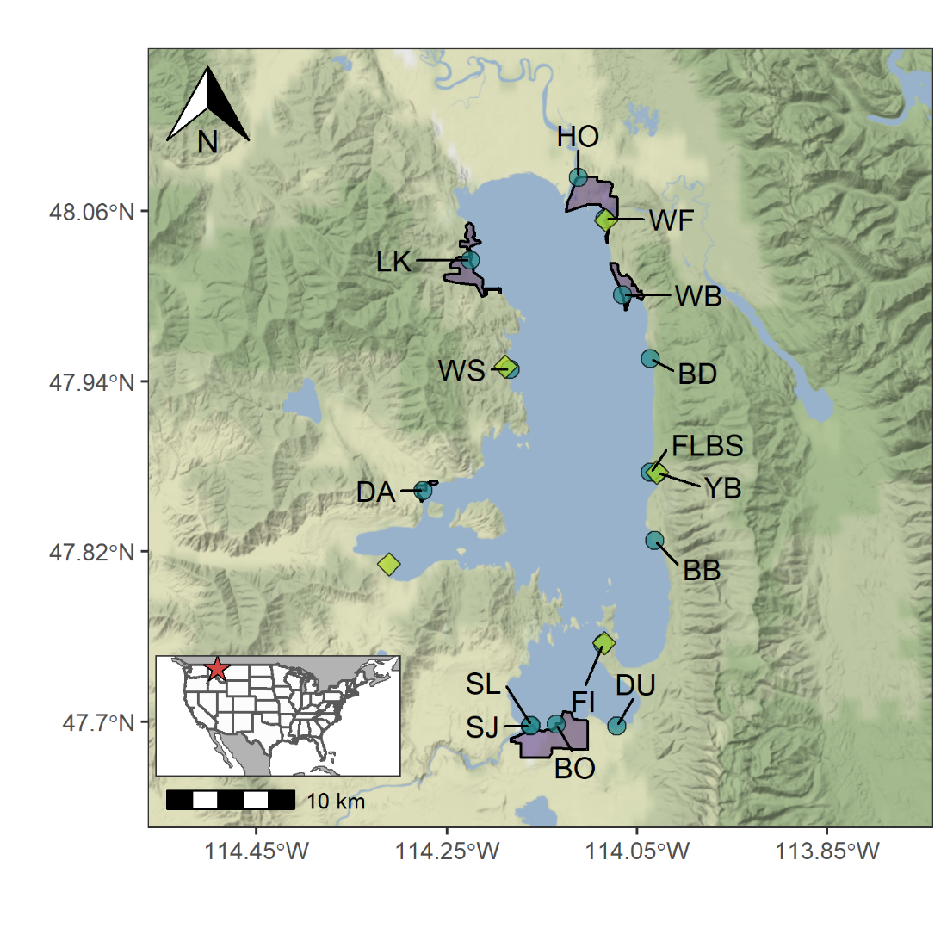

Figure 1: Map of sampling locations, state parks, and major lakeside developments. Sampling locations are denoted by the blue circles and are labeled with the site name. HO and DU were considered reference sites, where HO was sampled within the Flathead River before it enters Flathead Lake and DU was sampled where there was no adjacent lakeside development. Green diamonds correspond to locations of five state parks, from which we gather monthly visitor passes sold. Many sampling locations (blue circles) and state parks (green diamonds) were at the same location, and so they may slightly overlap. Purple polygons refer to area delineated for five major lakeside developments (Bigfork, Lakeside, Wood’s Bay, Dayton, and Polson).

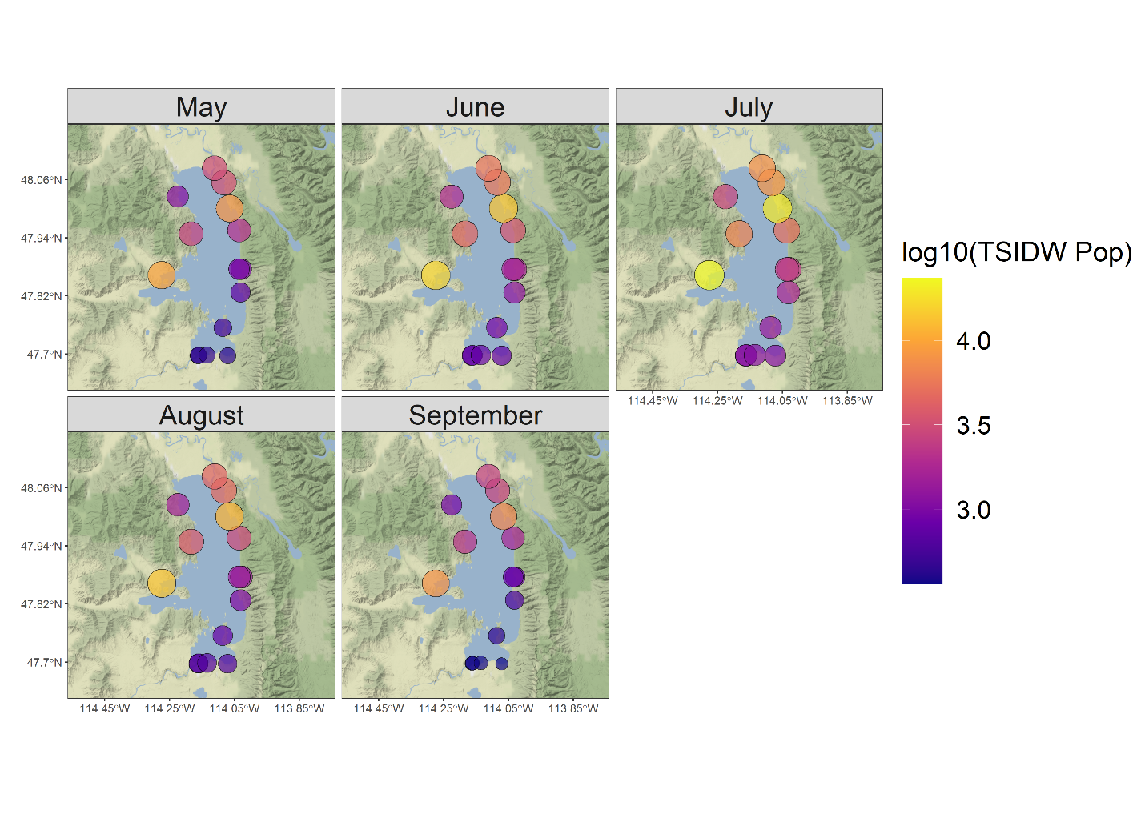

Figure 2: Temporally scaled inverse distance weighted (TSIDW) population for each sampling location and month. Spatially, TSIDW population tended to be highest in the northeast portion of the lake, near the towns of Bigfork and Wood’s Bay. Temporally, TSIDW population tended to be highest in July. TSIDW population values have been log-transformed so as to make sites more comparable across multiple orders of magnitude.

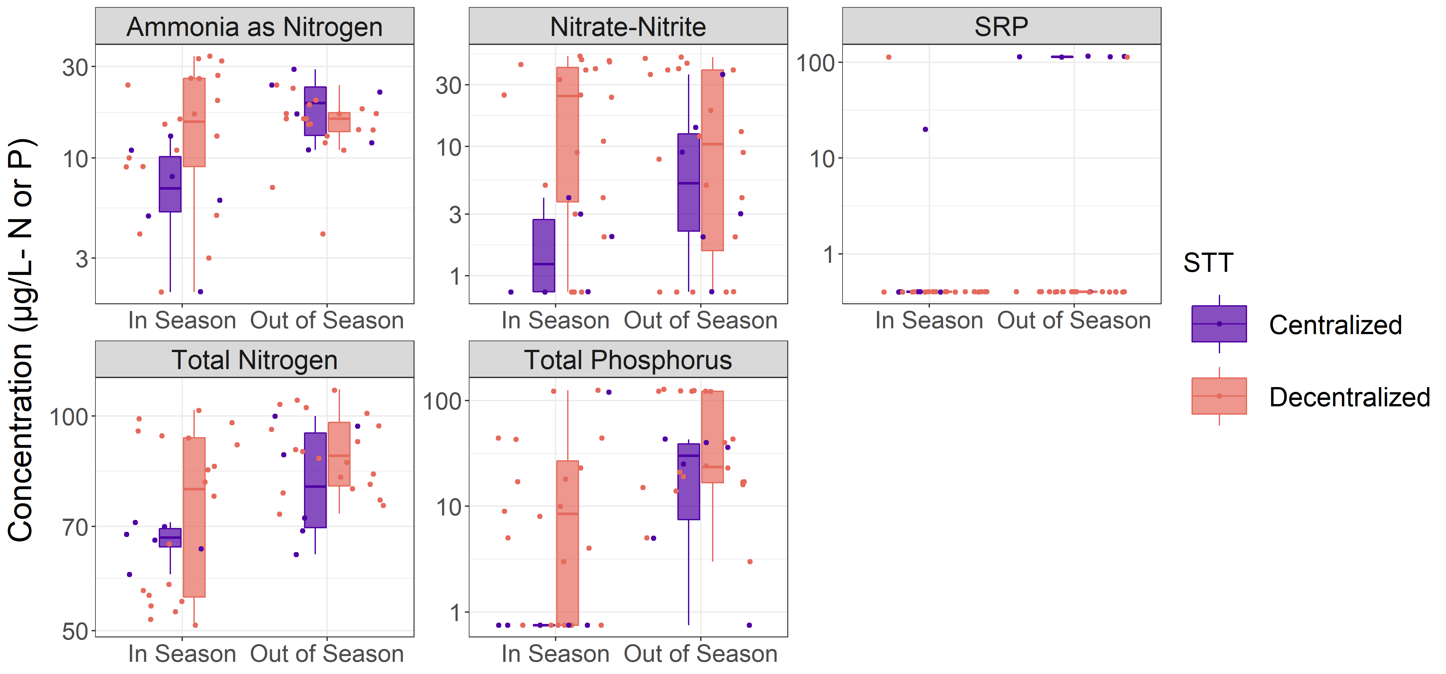

Figure 3: Littoral water column nutrient concentrations observed at each of the 15 sampling locations. Many SRP concentrations were below detection limits, resulting in many points being clustered at the lower end of the axis and several points (mostly associated with centralized sites following the tourist season) being clustered together.

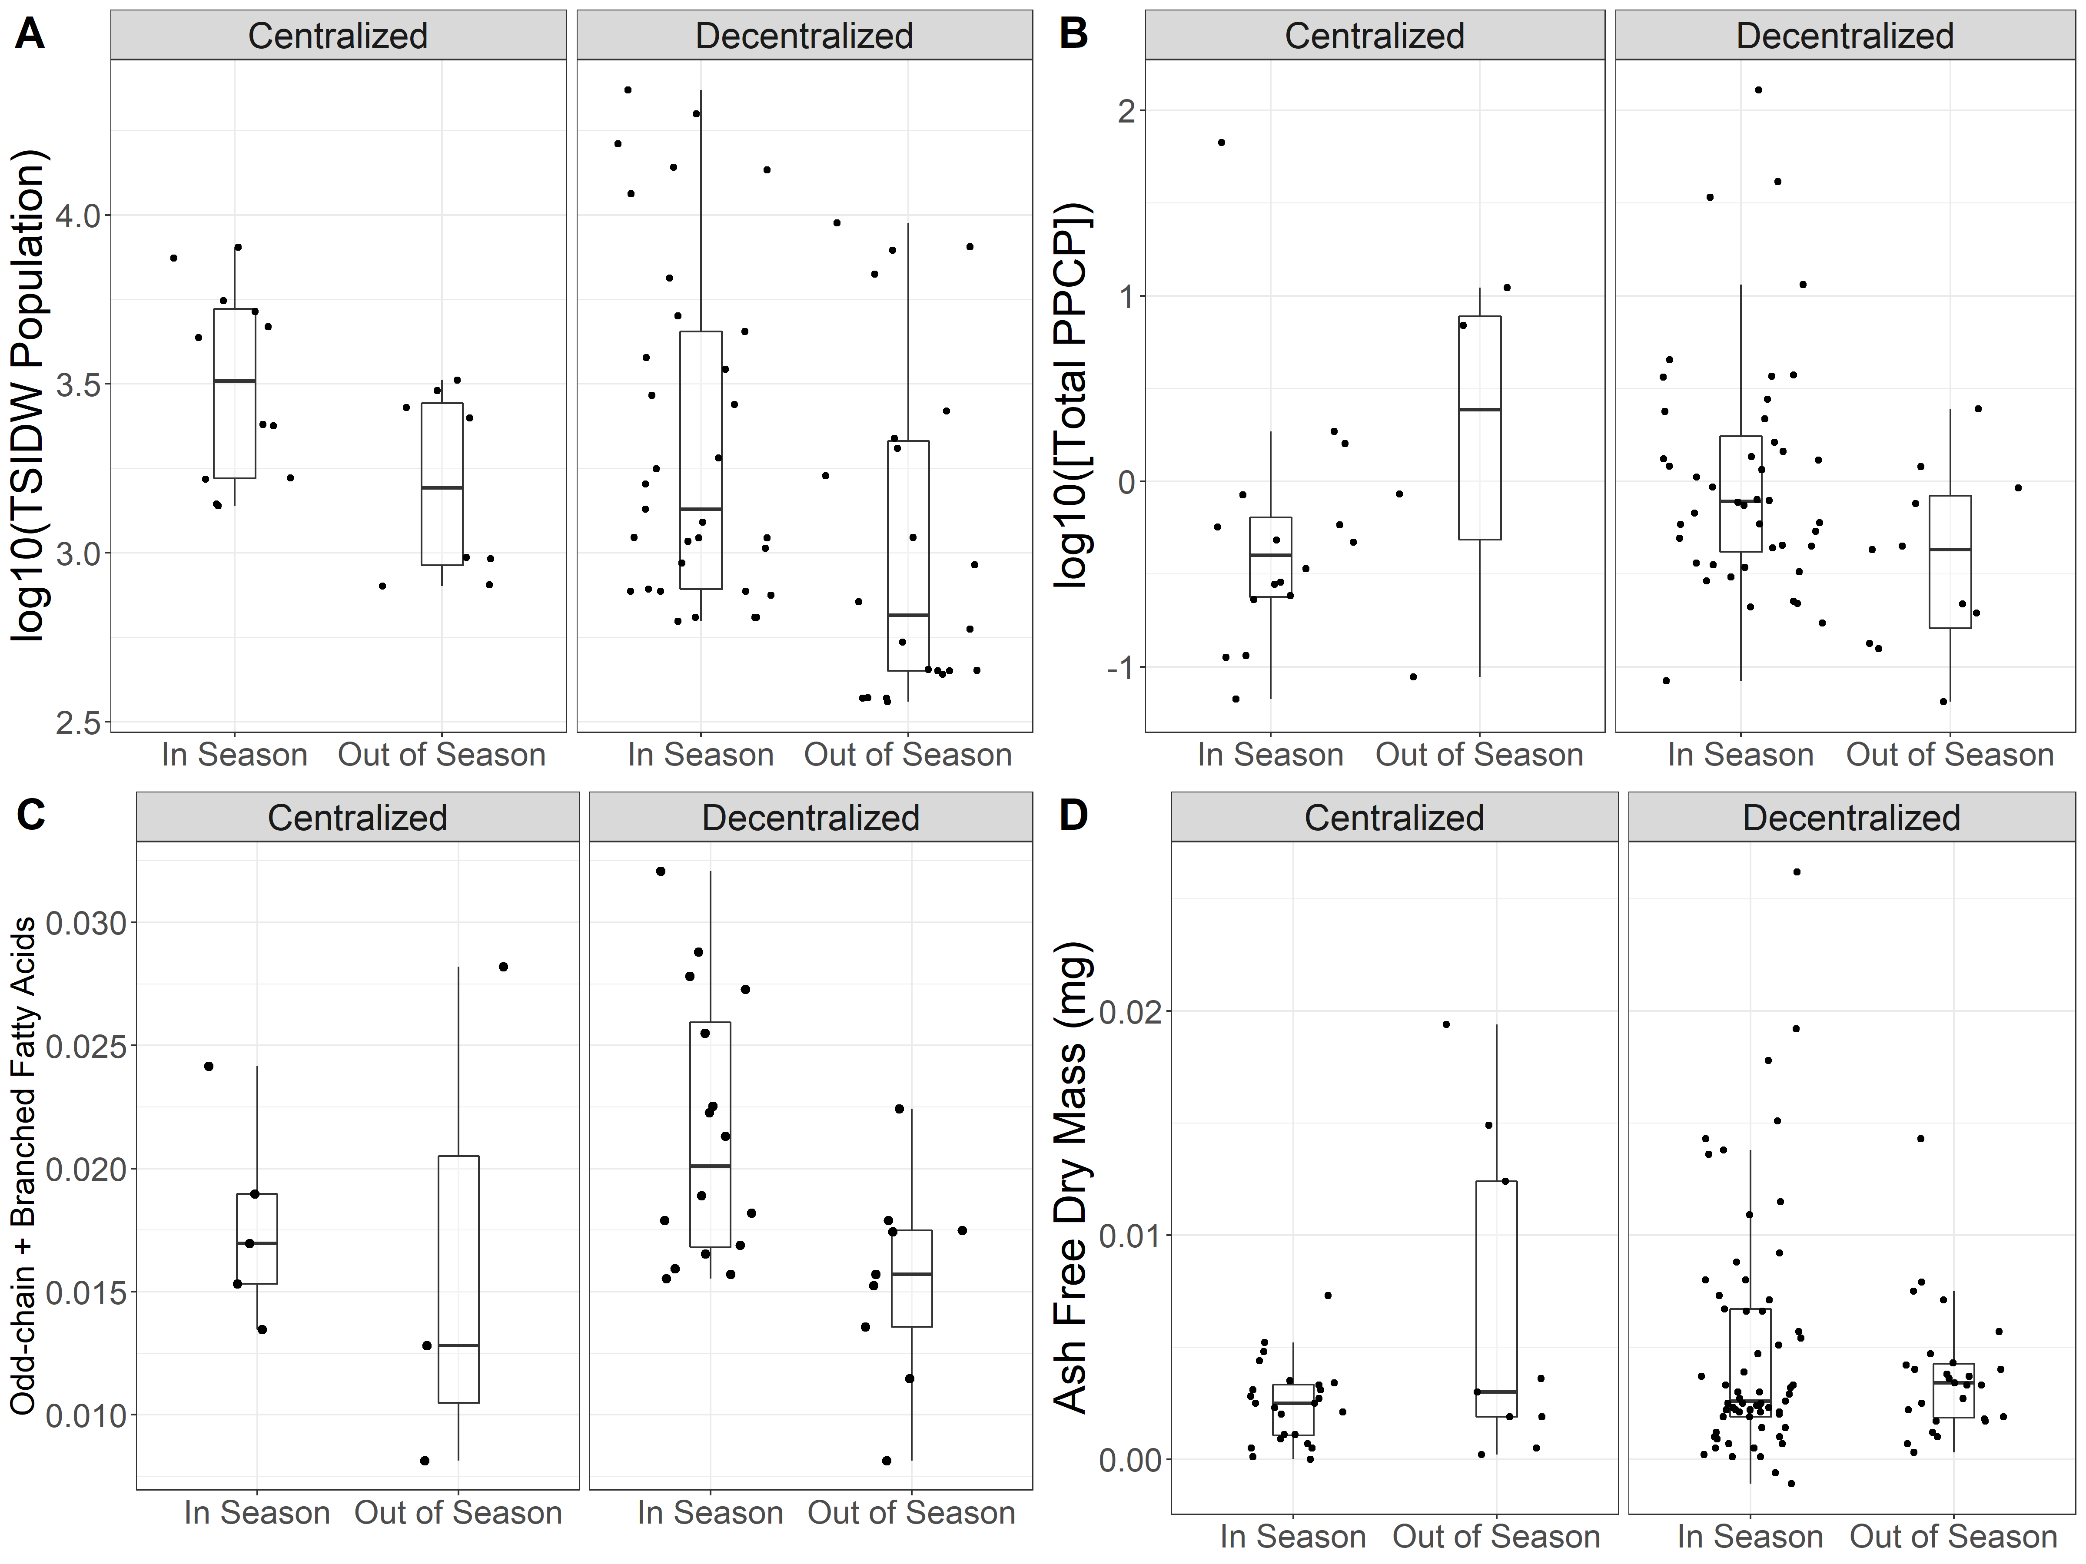

Figure 4: Boxplots of TSIDW population (A), total PPCP concentration (B), relative abundance of branched and odd-chain fatty acids (C), and Ash Free Dry Mass (D) in response to tourist season (x-axis) and sewage treatment technique (faceted axis). TSIDW Population (A) generally tended to be higher at sites with centralized wastewater treatment and also decreased following the tourism season both for sites with centralized and decentralized wastewater treatment. Total PPCP concentrations (B) tended to be higher at sites with decentralized wastewater treatment during the tourism season than at those same sites following the tourism season. Periphyton odd- and branched-chain fatty acids (C) tended to be higher during tourism season both for sites with centralized and decentralized wastewater treatment. These fatty acids tend to be indicative of bacterial communities, which would be expected to be more abundant during times and at locations of increased wastewater loading. Ash Free Dry Mass (D), a proxy for periphyton productivity, was consistent between sites in relation to sewage treatment technique and tourism season.

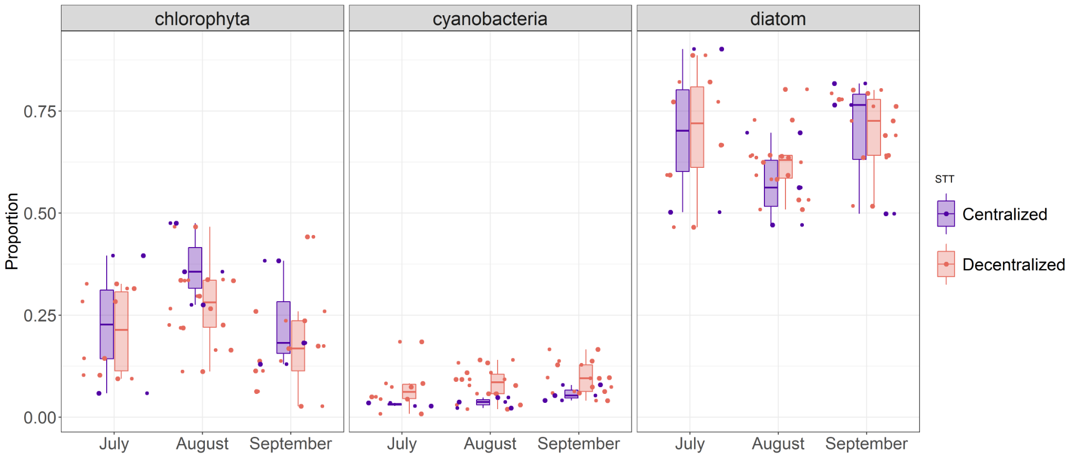

Figure 5: Boxplots of algal taxonomic group proportional abundance throughout the course of a summer. Sites with centralized wastewater treatment were generally dominated by chlorophyta and diatoms, whereas sites with decentralized treatment tended to have a more marked cyanobacteria abundance that gradually increased over the course of a summer.

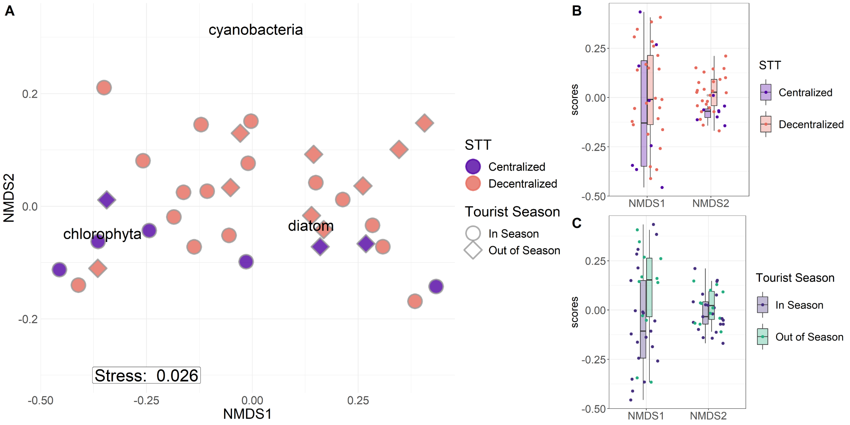

Figure 6: NMDS biplot (A) and boxplots of NMDS axis values when points are grouped by sewage treatment technique (B) and tourist season (C). The NMDS biplot suggested that sites did not separate based on multivariate patterns is algal community composition, but rather sites with centralized wastewater treatment tended to have lower overall cyanobacterial presence. This same pattern was observed in the univariate analysis (Figure 5). When considering processes underpinning each NMDS axis, NMDS1 tended to reflect temporal differences in community composition, which were likely brought about from the tourist season and community succession. NMDS2 seemed more reflective of relative cyanobacteria presence (A). Although sites did not significantly differentiate based on multivariate patterns in community composition, univariate analysis suggested that NMDS2 values were significantly different based on sewage treatment technique (B) but not tourist season (C).

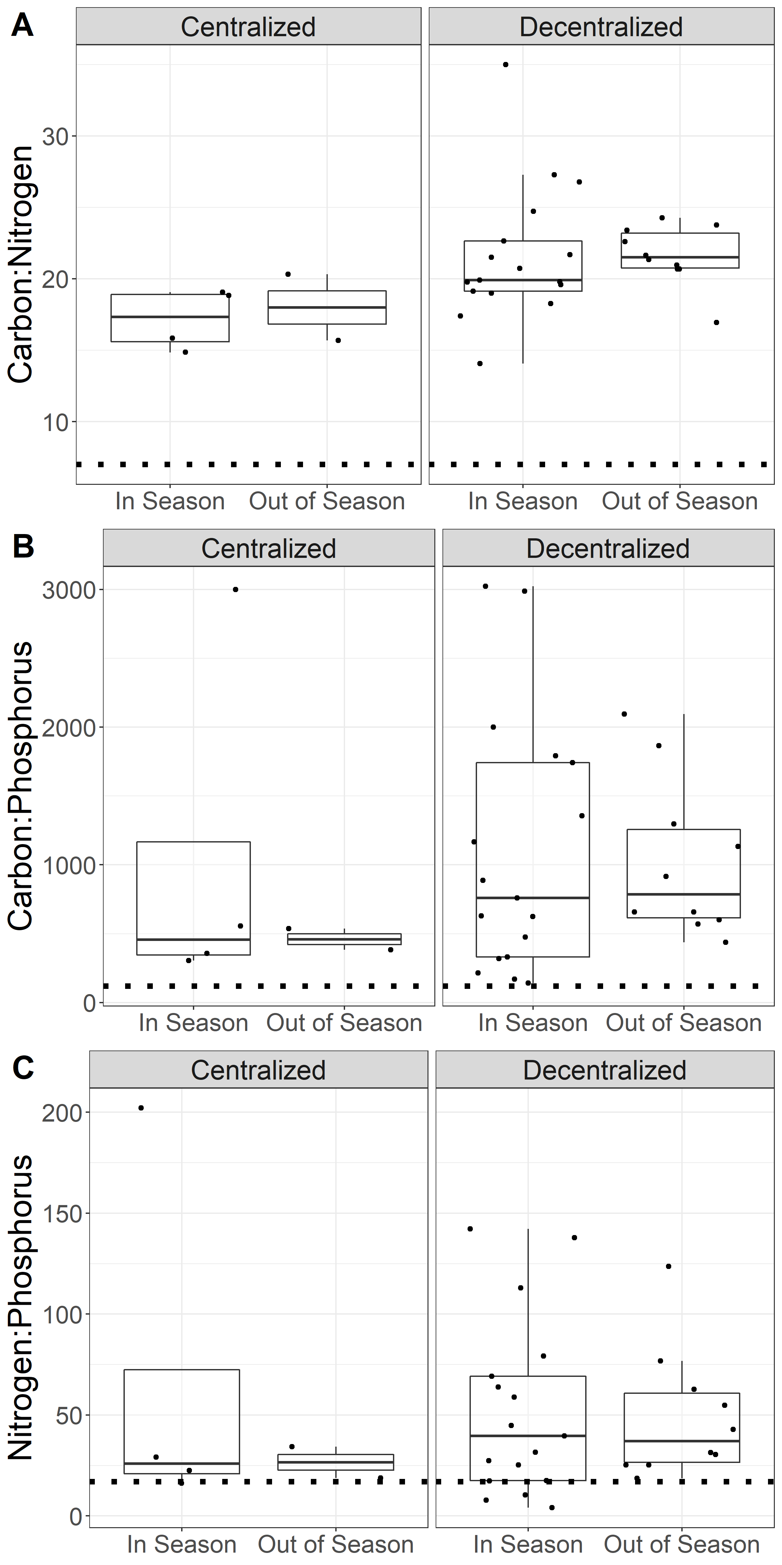

Figure 7: Molar Carbon:Nitrogen (A), Carbon:Phosphorus (B), and Nitrogen:Phosphorus (C) ratios for periphyton with samples groups by whether sites were located near centralized or decentralized wastewater treatment or samples were collected during or following the tourist season. “In Season” denotes samples collected during June, July, or August, whereas “Out of Season” denotes samples collected in September. Dotted lines in each plot reflect the empirically derived stoichiometric ratios for non-nutrient limited growth of periphyton communities (i.e., 119:17:1; Hillebrand and Sommer 1999).

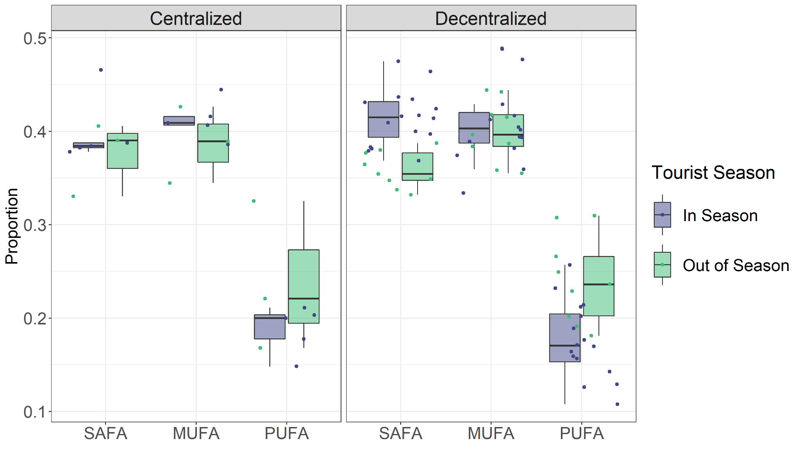

Figure 8: Relative concentrations of saturated (SAFA), monounsaturated (MUFA), and polyunsaturated (PUFA) fatty acids in periphyton with samples groups by whether sites were located near centralized or decentralized wastewater treatment or samples were collected during or following the tourist season. “In Season” denotes samples collected during June, July, or August, whereas “Out of Season” denotes samples collected in September.

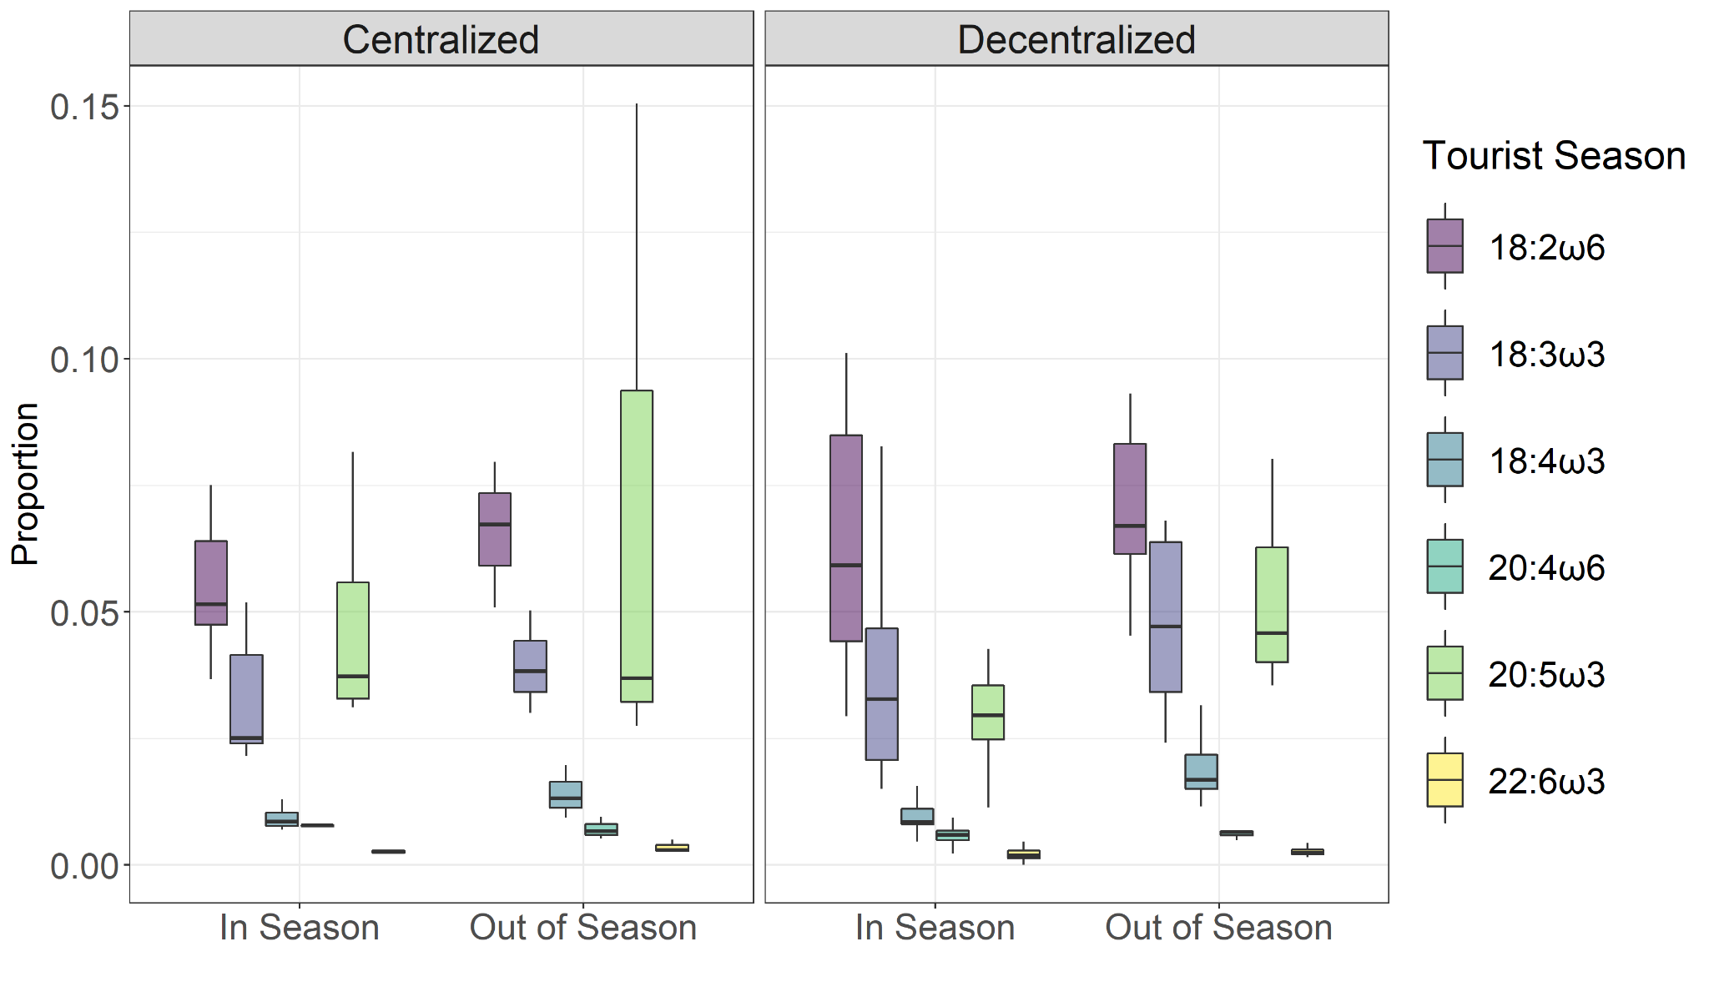

Figure 9: Relative concentrations of essential fatty acids (EFAs) in periphyton with samples groups by whether sites were located near centralized or decentralized wastewater treatment or samples were collected during or following the tourist season. “In Season” denotes samples collected during June, July, or August, whereas “Out of Season” denotes samples collected in September. EFAs are considered highly nutritious fatty acids for higher trophic levels and are primarily synthesized by primary producers. Greatest differences in EFAs between locations and timepoints occurred at sites with decentralized sewage treatment, which contained increased 20:5ω3 following the tourist season. Because fatty acids tend to map to algal community compositions, this increased 20:5ω3 signature was likely related with increased diatom abundance (Figure 5).

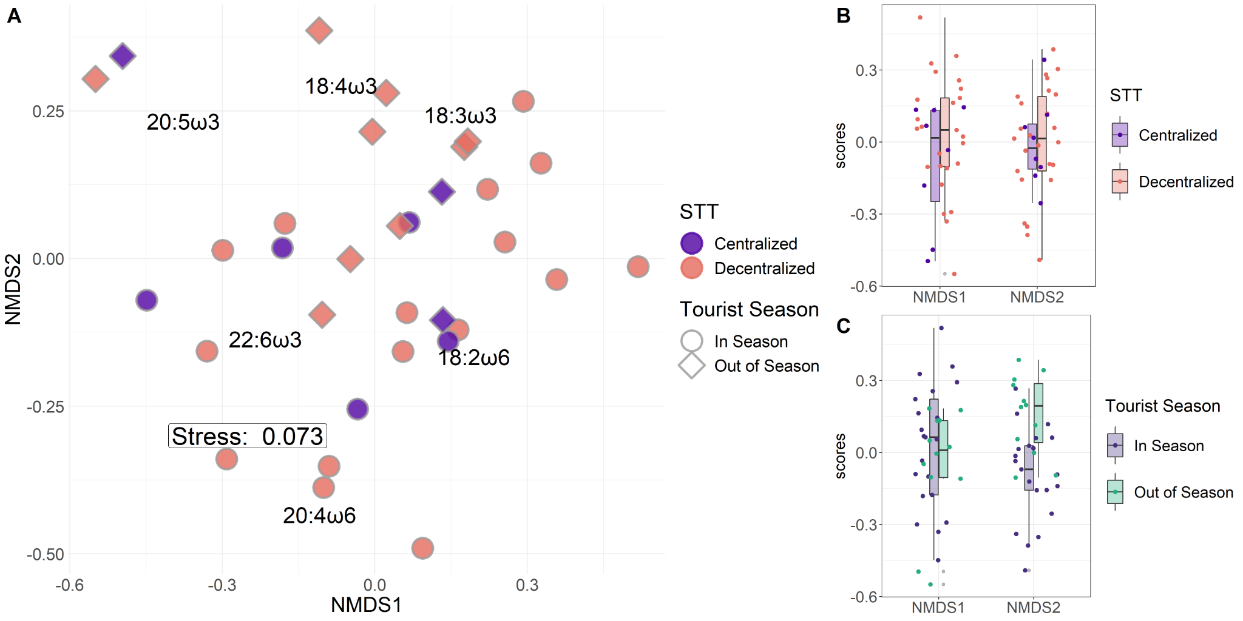

Figure 10: NMDS biplot based on EFA relative abundance (A) and boxplots of NMDS axis values when points are grouped by sewage treatment technique (B) and tourist season (C). The NMDS biplot suggested that sites separated significantly by differences in tourist season (circles and diamonds; PERMANOVA p = 0.01). Post hoc SIMPER analyses suggested 20:5ω3 relative abundance as the most influential EFA in driving point separation. This same pattern was observed in the univariate EFA analysis (Figure 9). When considering processes underpinning each NMDS axis, NMDS1 tended to reflect temporal differences in EFA composition, which were likely brought about from the tourist season and community succession. For example, chlorophytes usually contain mixtures of 18-Carbon ω-3 EFAs, whereas diatoms tend to contain mixtures of 20-Carbon ω-3 EFAs. NMDS2 seemed more reflective of relative ω-3 and ω-6 abundances (A). Univariate analyses corroborated multivariate interpretations that NMDS2 values were significantly different based on tourist season (C) but not sewage treatment technique (B).